# CSI-899 Fall 2022

Joseph J. Boone

G#:

This summary is oranized on a week-by-week basis.

## 2022-August-26 (Week 1)

Week 1

This week we had a talk by Rob Axtel covering his time away from GMU including the following topics:

1. Green benchmarks are a thing – do we care?
2. Digital Twins
3. Physics based methods for Computational Social Sciences
4. Multi-layer ABMs (ABM’s where the agents themselves are ABMs), recursively

Green benchmarks are a thing - do we care?

Energy Consumed

Run faster => Less Energy

Class of languages “green” vs “brown”

How was Swift cheating?

CO2 produced graph

Like Python, perhaps other languages when coded by experts perhaps they didn’t control

Digital Twins – dissertation possibility??

“Mirror Worlds” to “Digital Twins”

Smart manufacturing

Industrial applications

Design implications

Control systems

Machine tool

Smart farming

Machine learning

Multi-scale modeling

Not so much in the social science, more in engineering currently

How to put together the various “layers”

Physics Methods – shouldn’t care…

Physics style methods “Starlings as Particles”

Renormalization group

ABMs of ABMS – what is this good for?

Austrian Economics

Methodological individualism (MI)

Each agent in the ABM should be an ABM

Keynes beauty contest

3 cars pull up to a 4 way stop

Adversarial situation

Each adversary builds a model of the other adversarys

Recursive models

k-level rationality

how practical

ICCS – Lessons from COVID modeling for policy – shared stage with Neil Ferguson

Can’t swamp the hospitals

Can make big mistakes

SDML

Spring – Complex Adaptive CSS-665 Policy Models

K-level games…mean level of k is 1.5

## Week 2 – No Class

## Week 3

In week 3, John Schuler presented his work on agent based models of bank runs. Key elements of his work include analysis of the Diamond-Dybvig band run model.

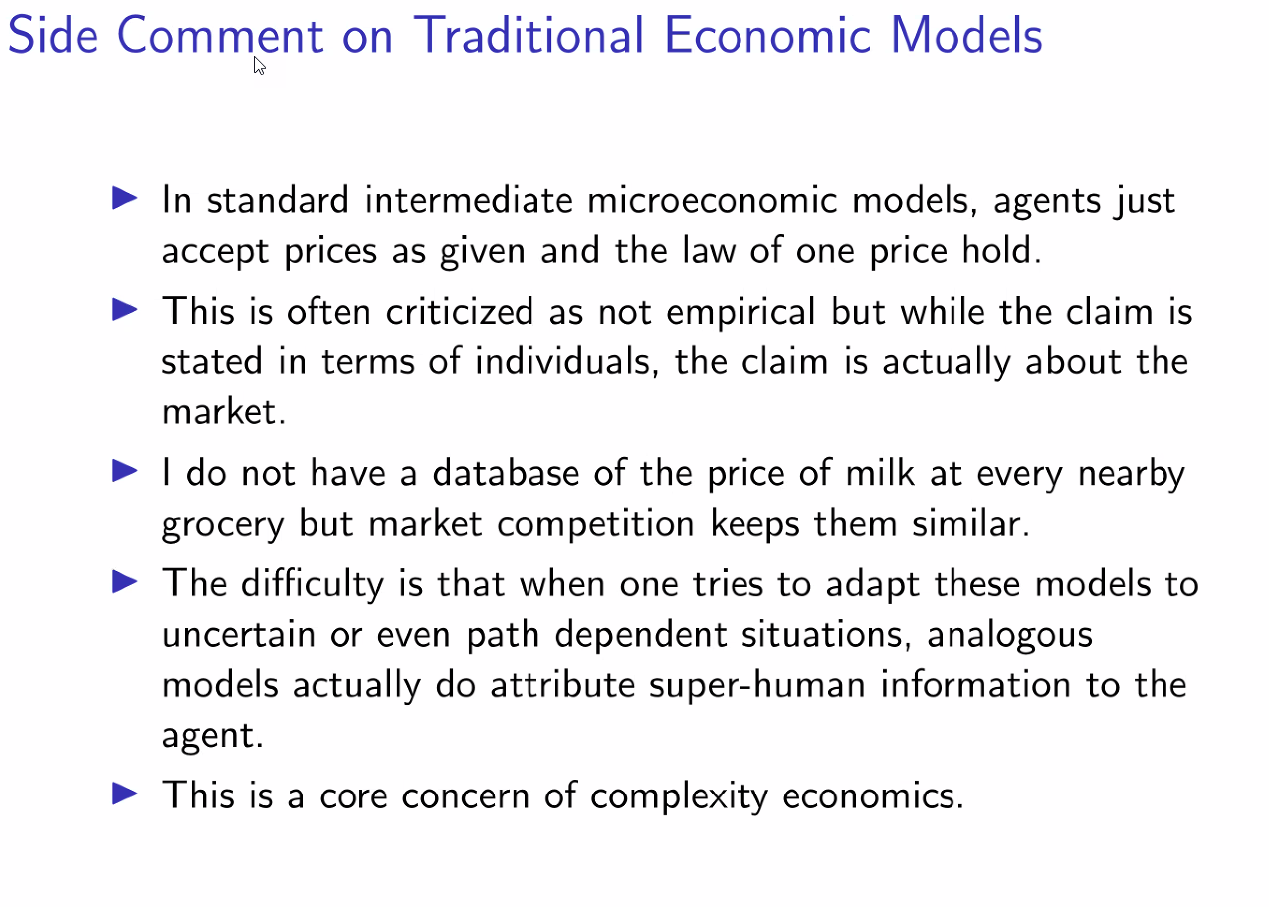

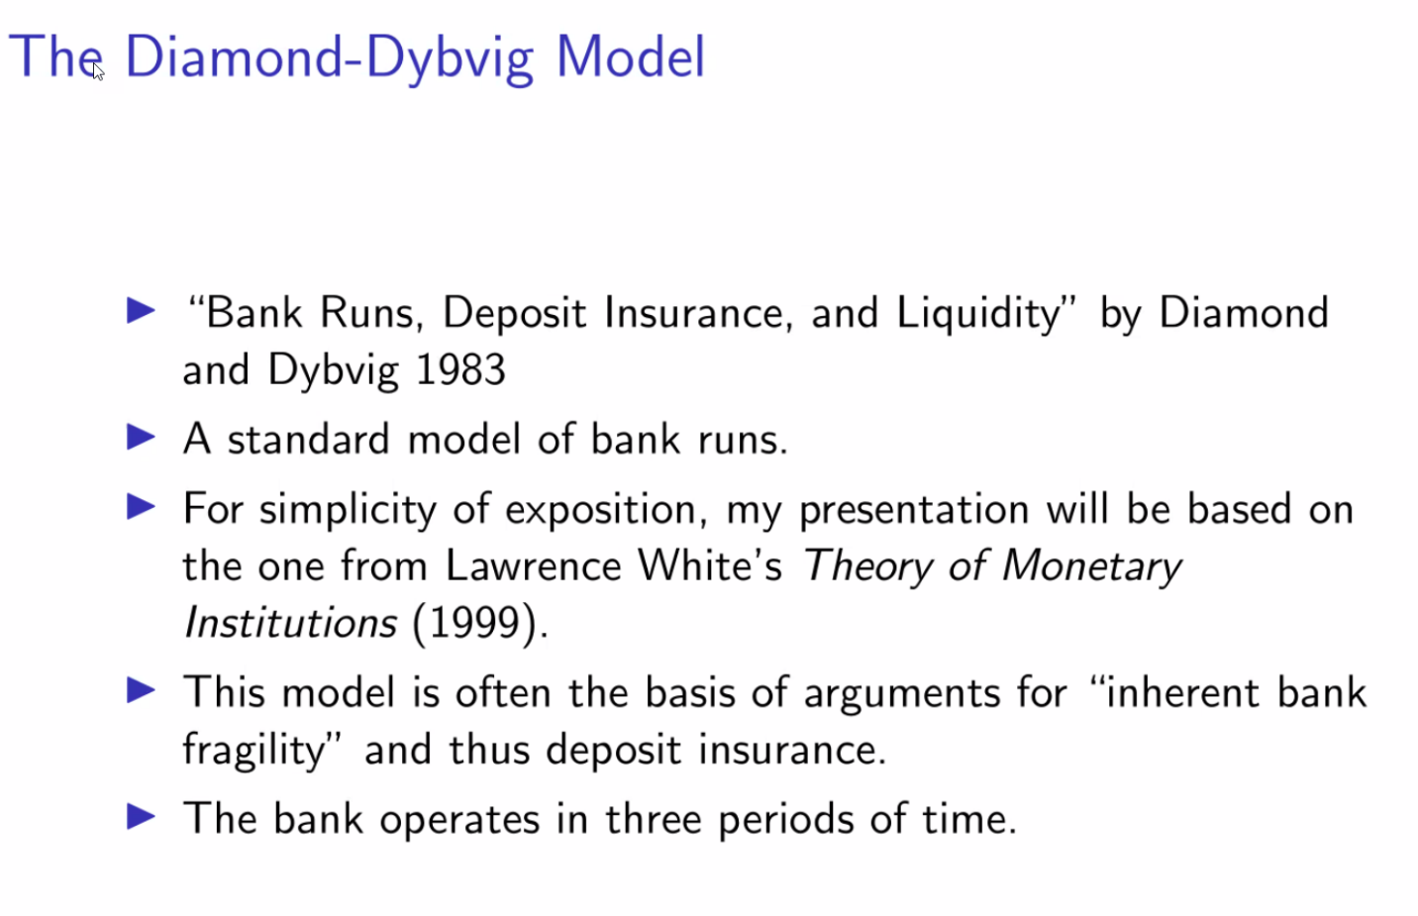

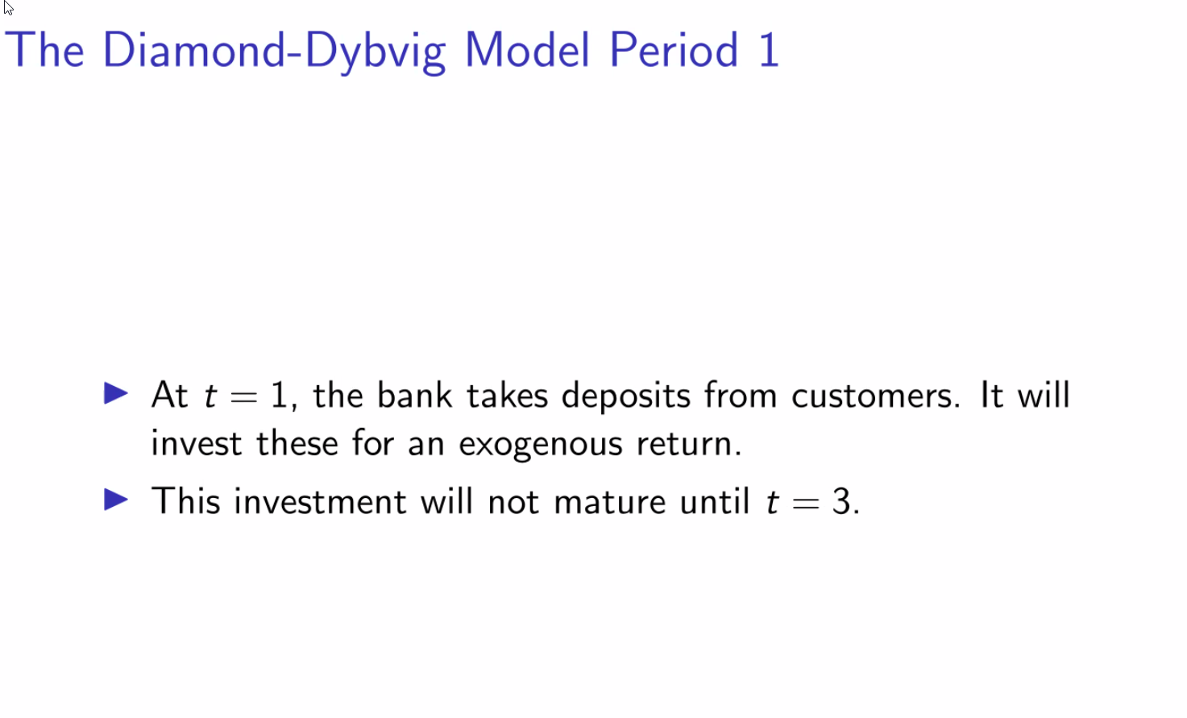

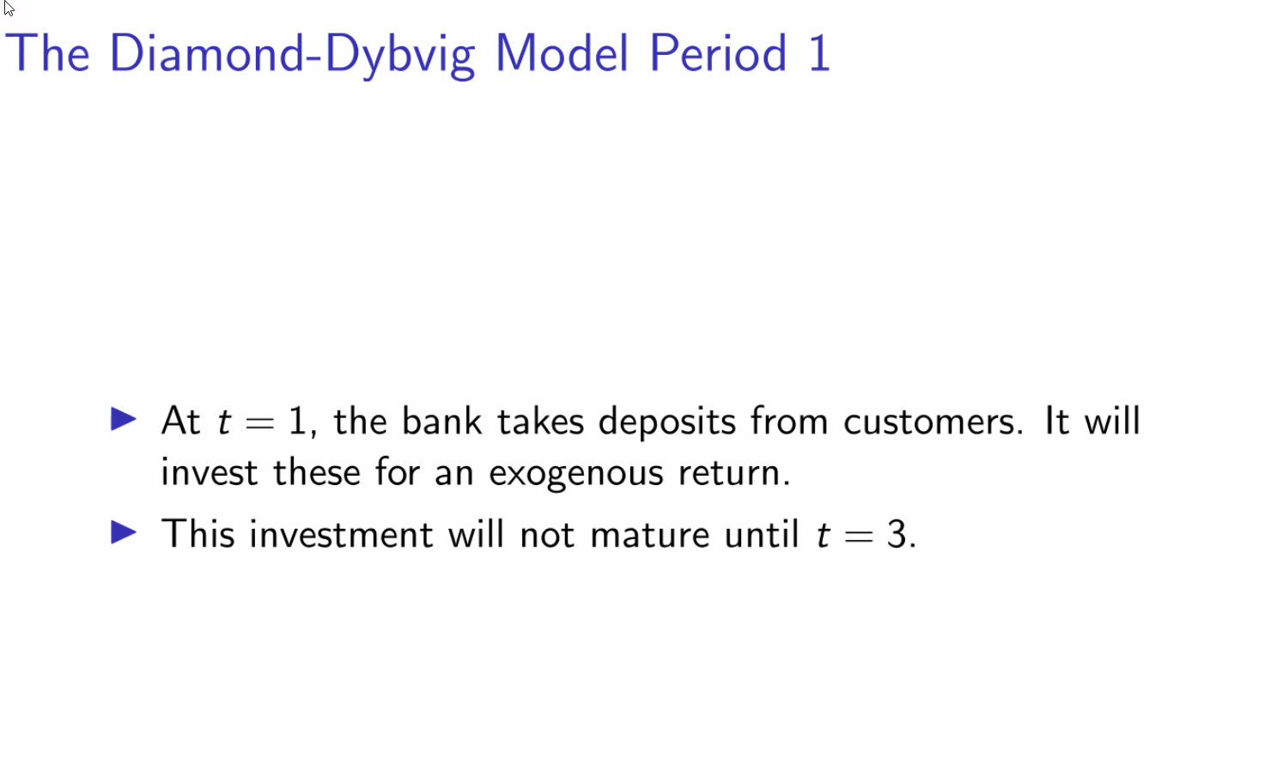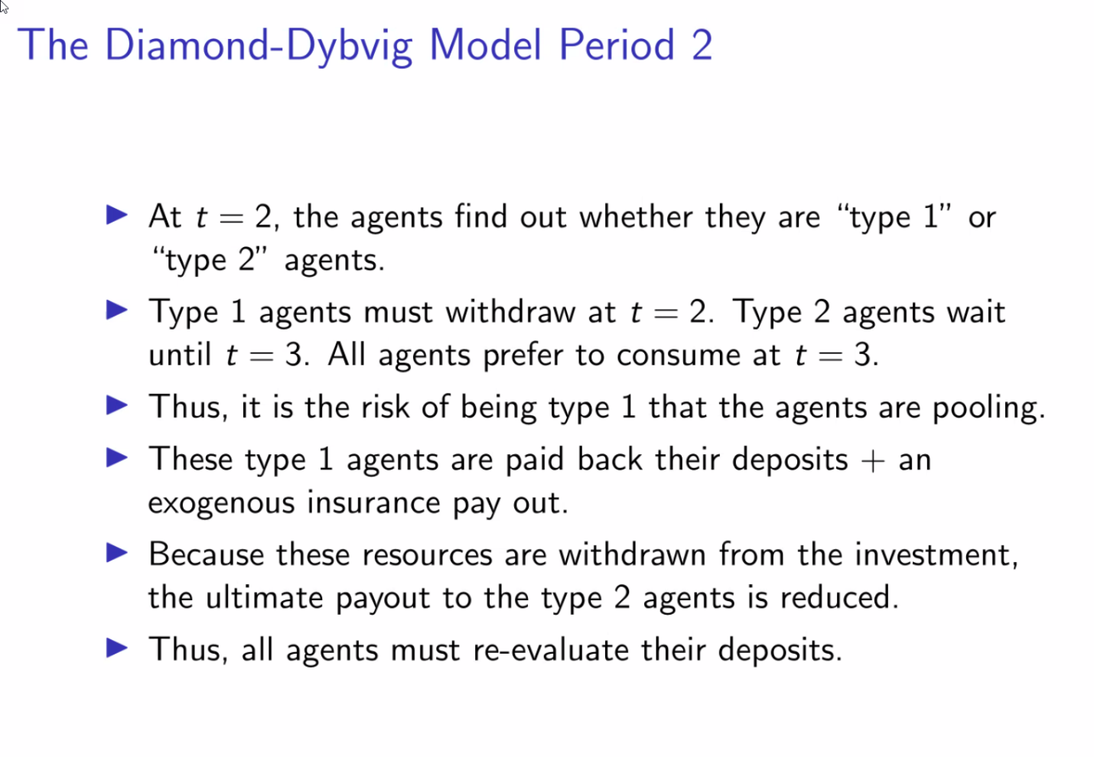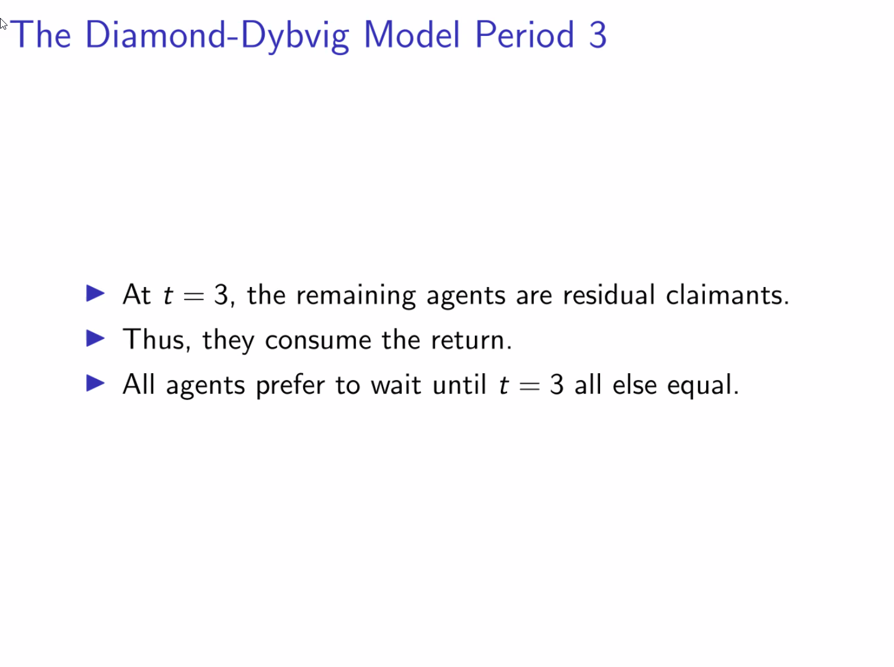

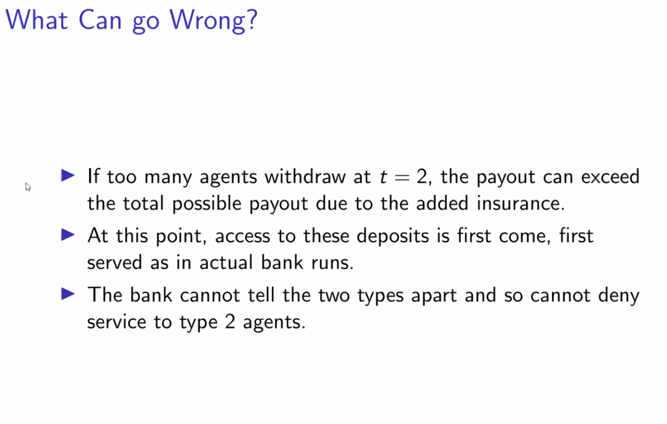

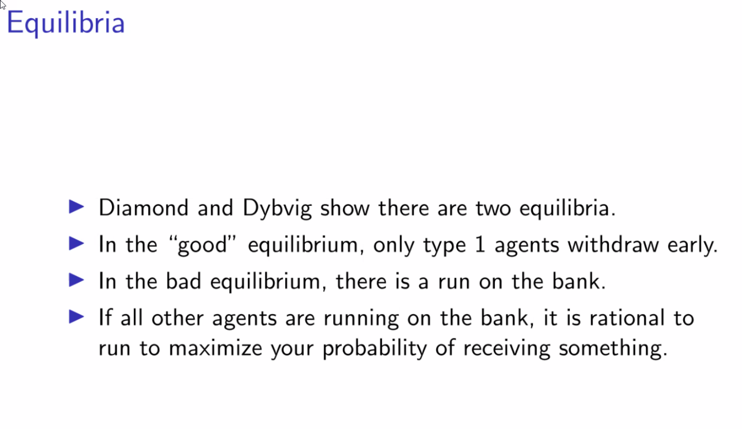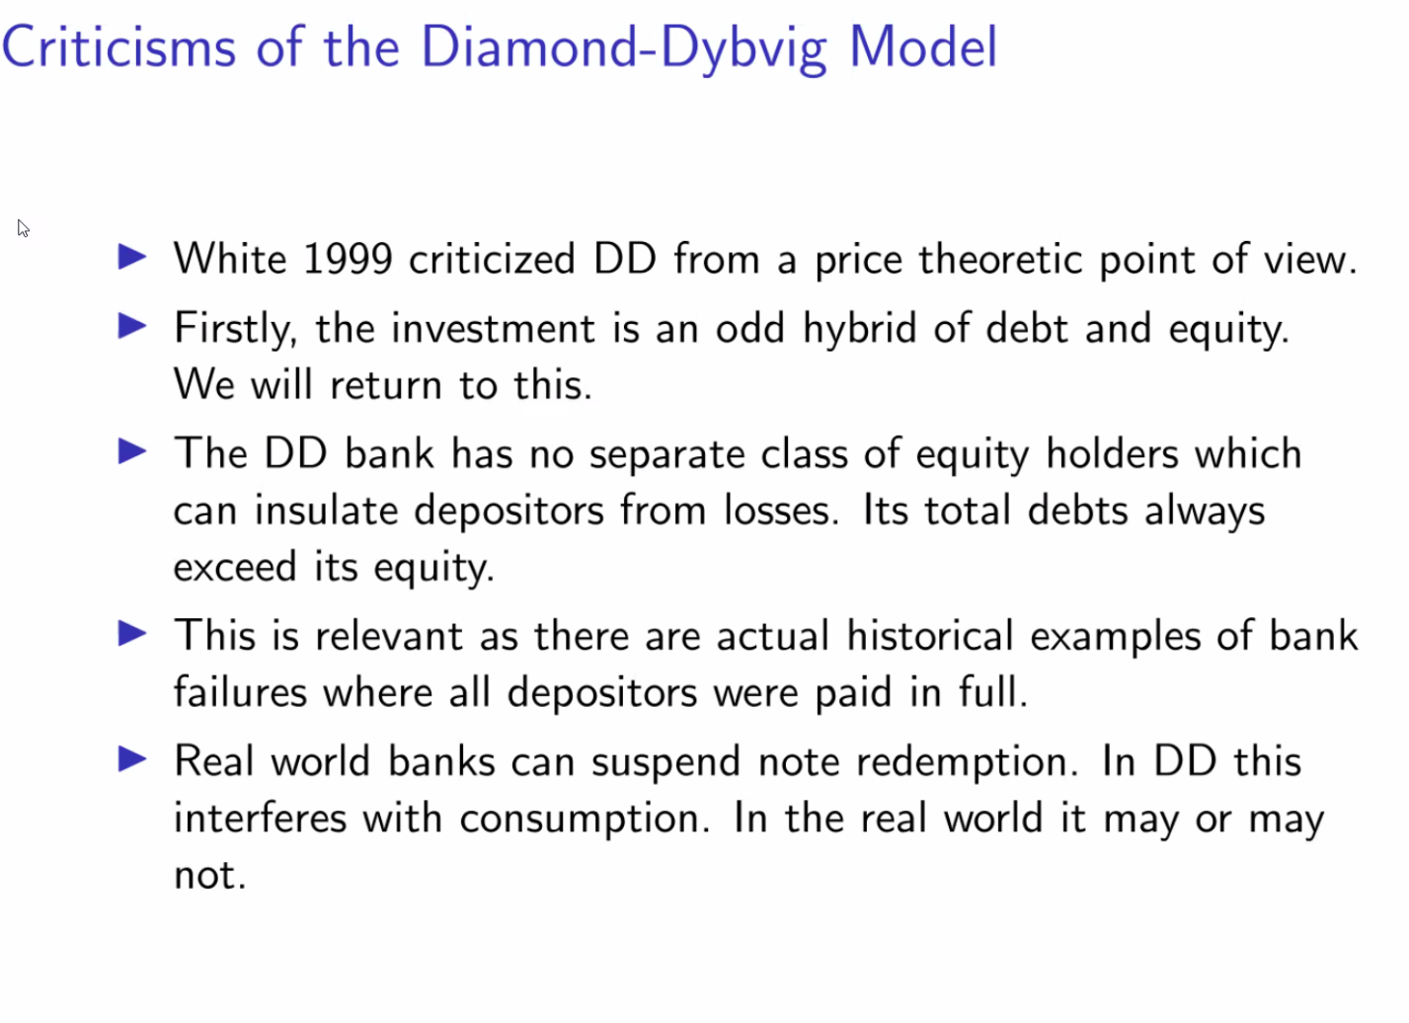

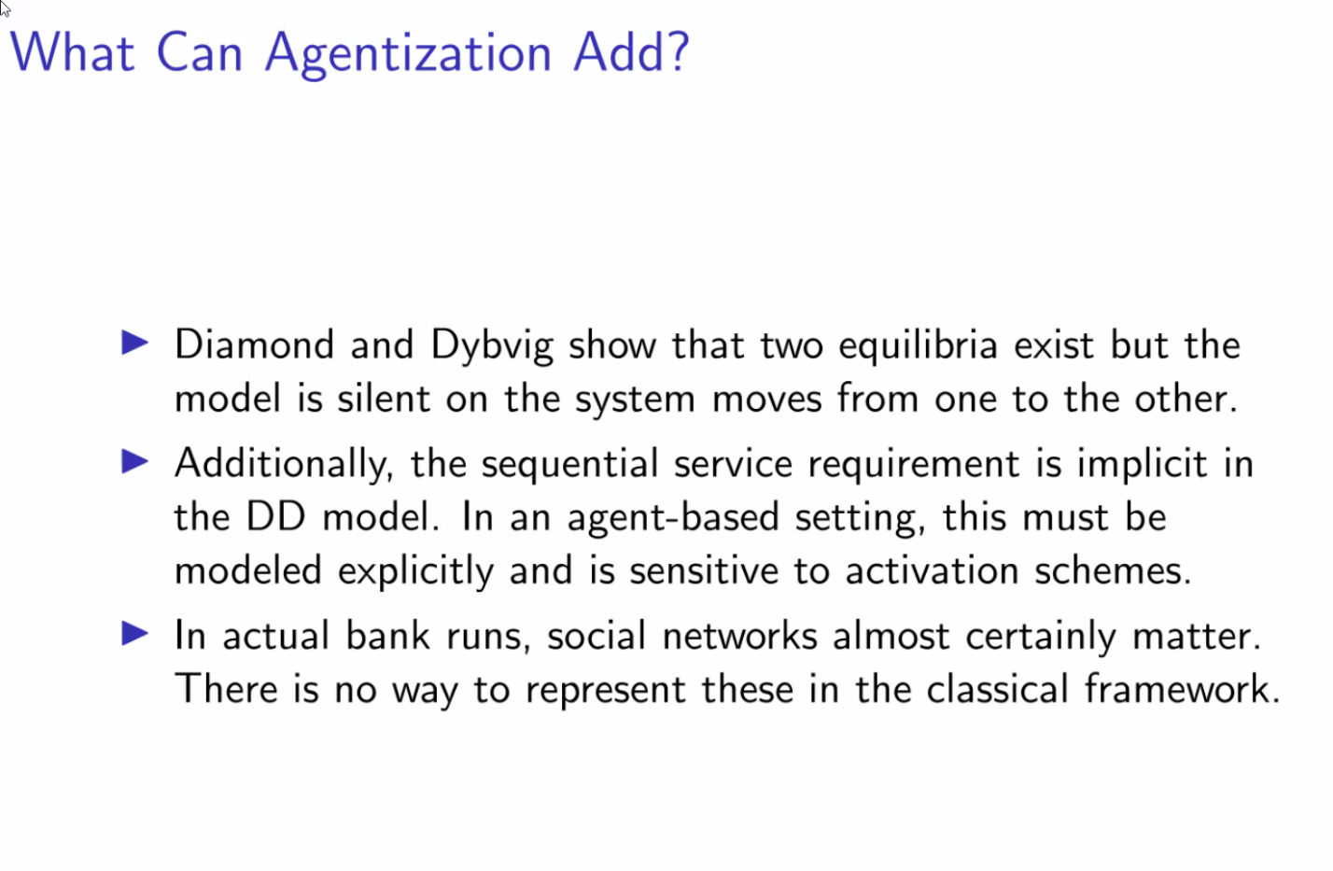









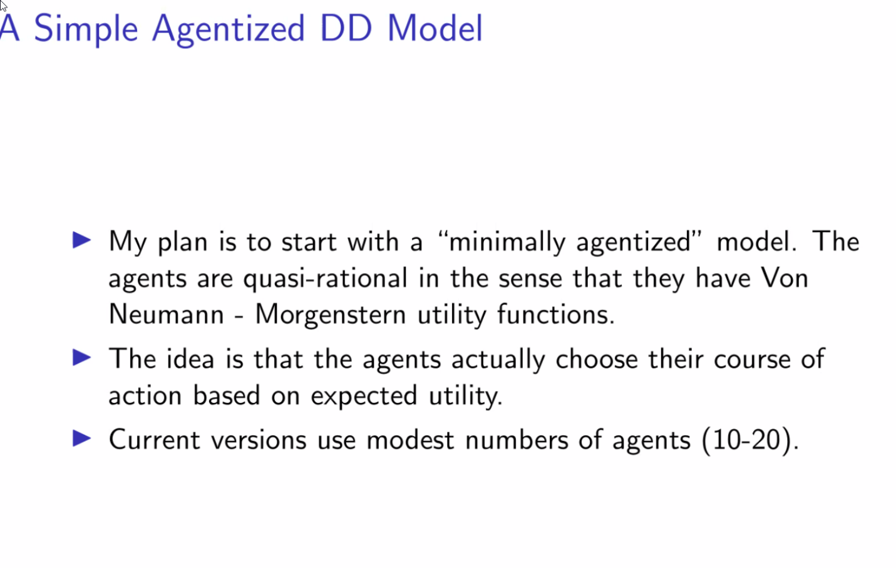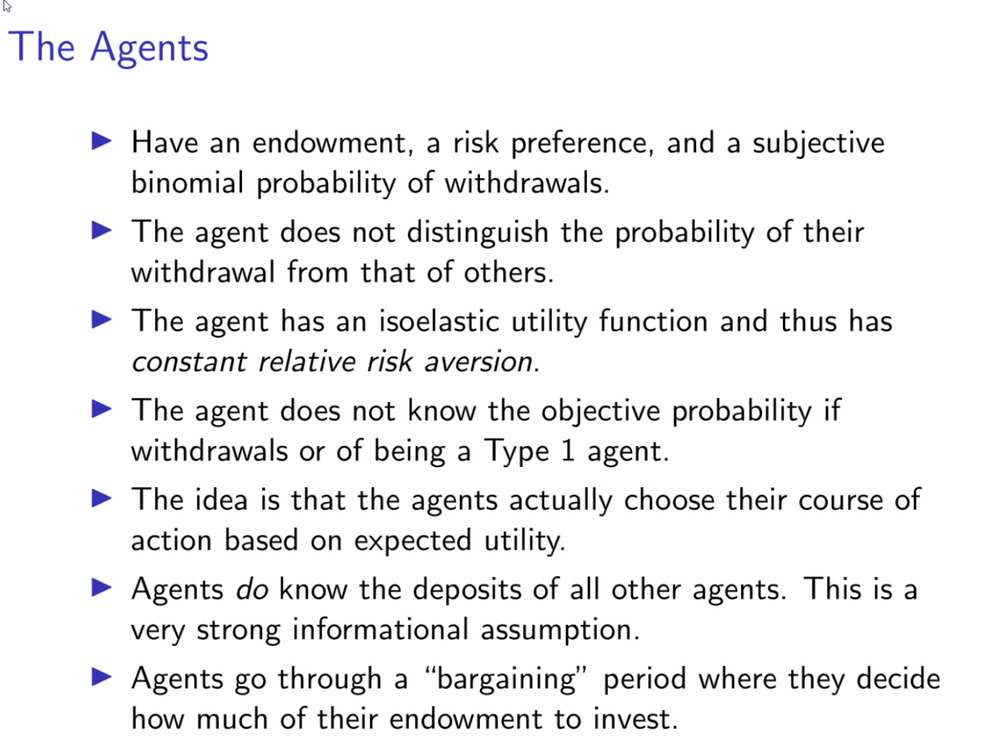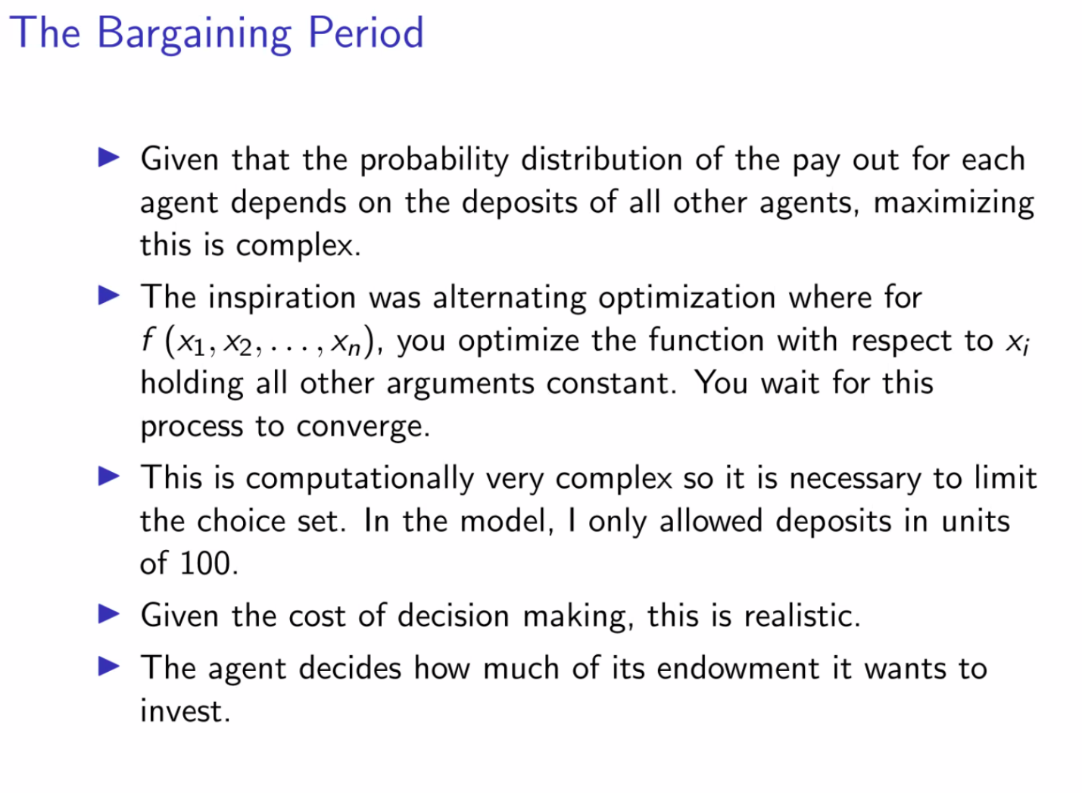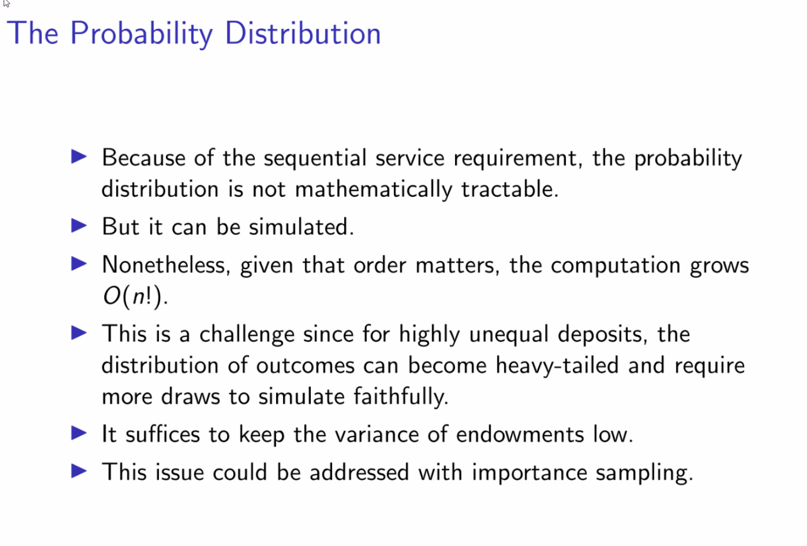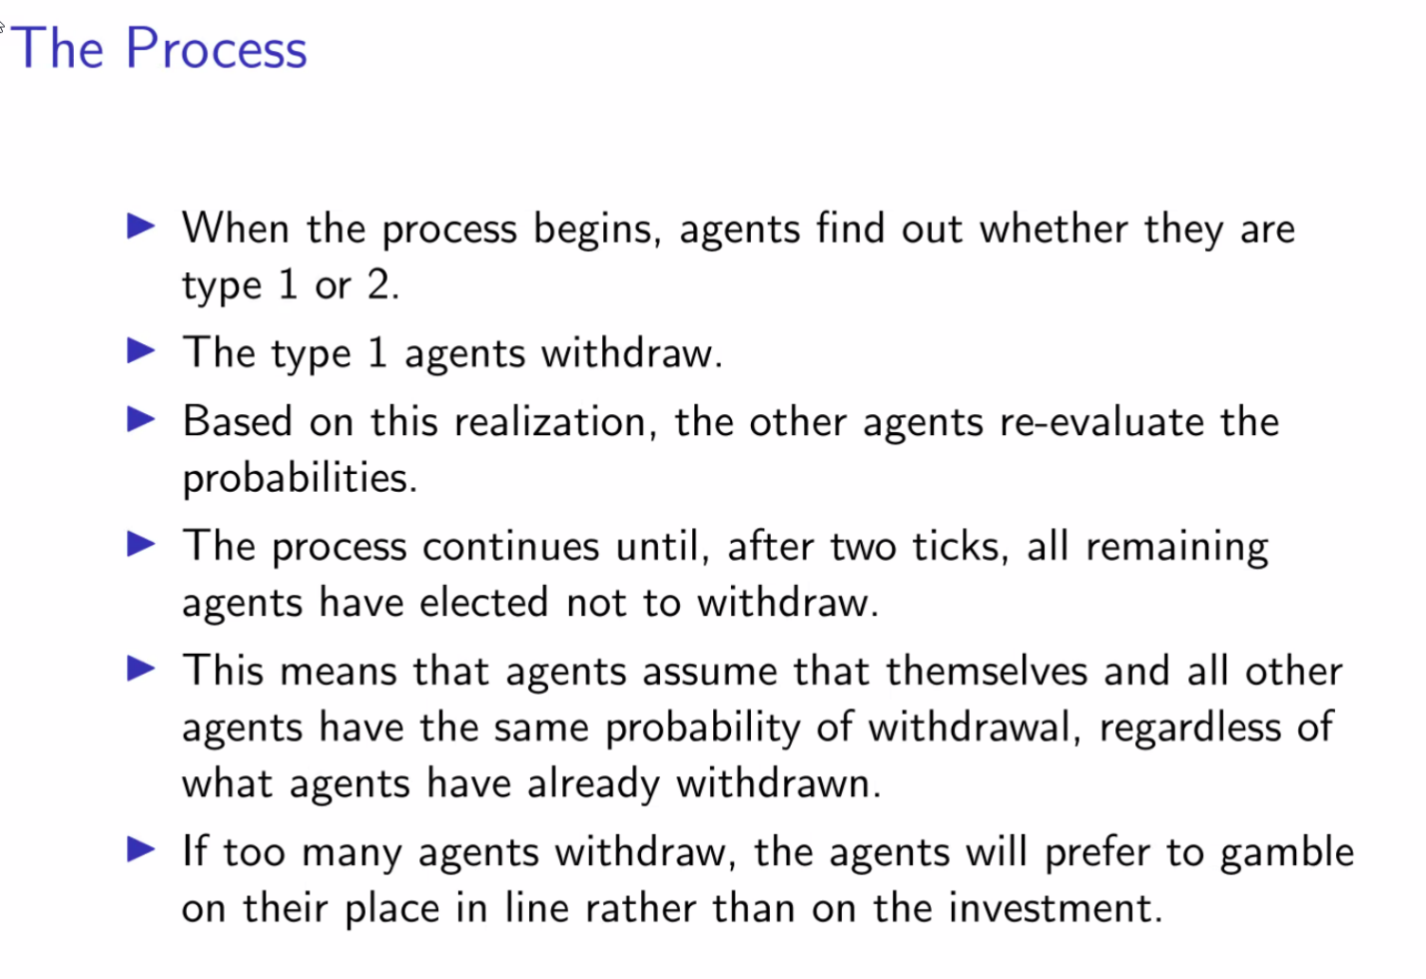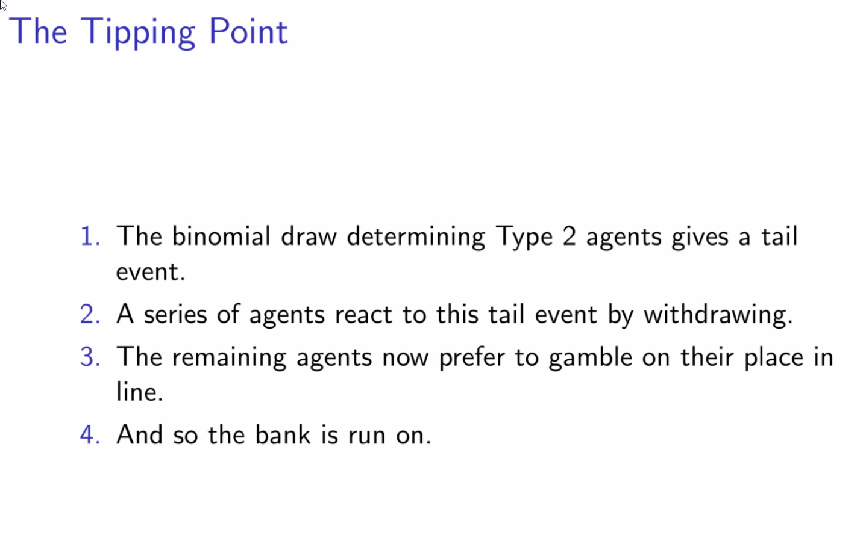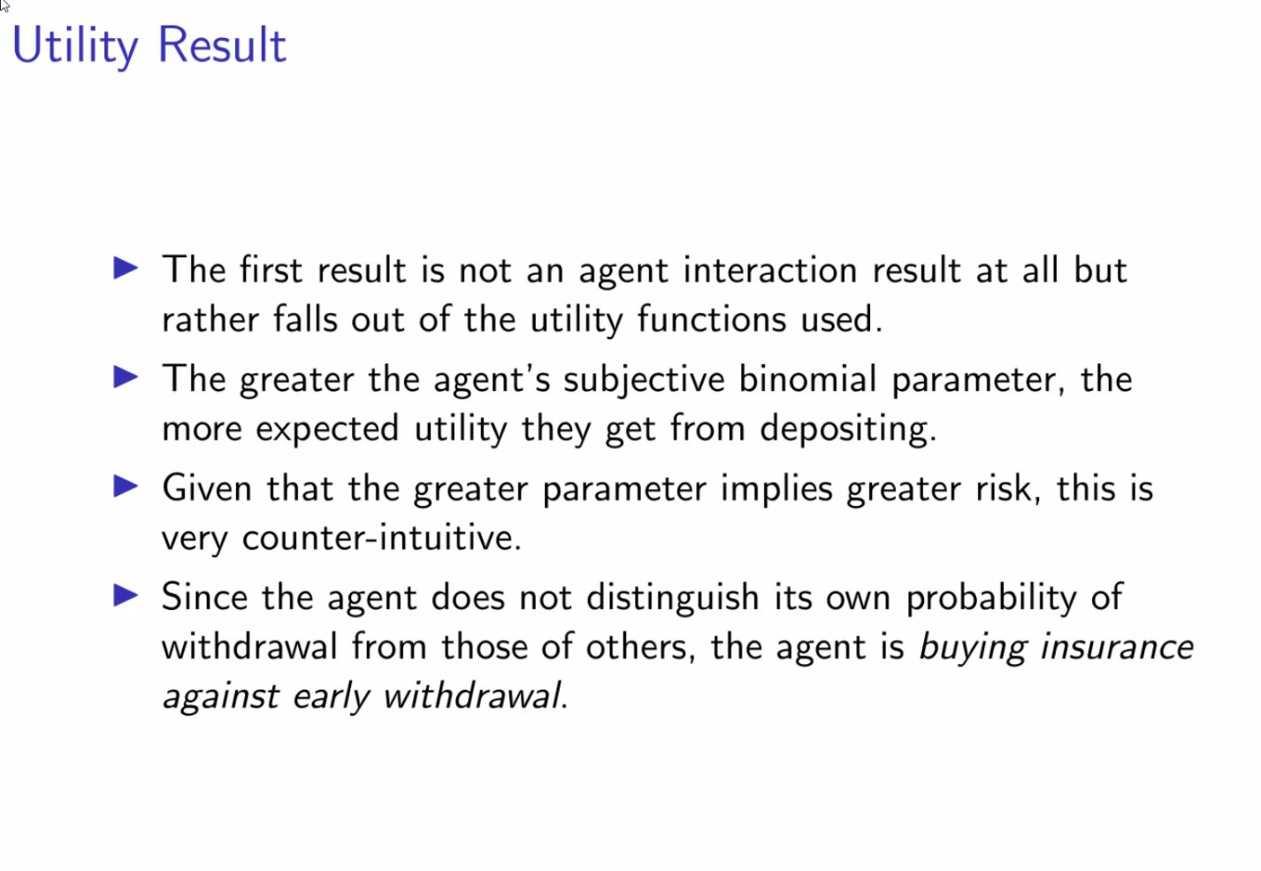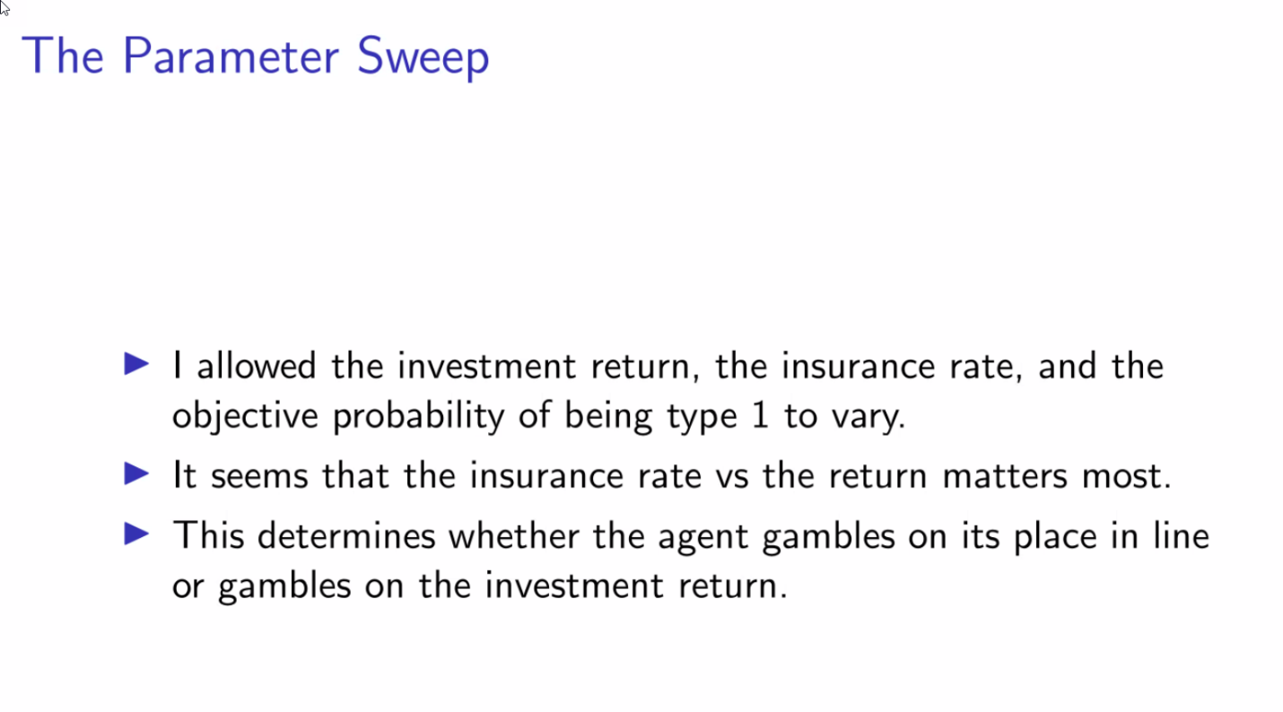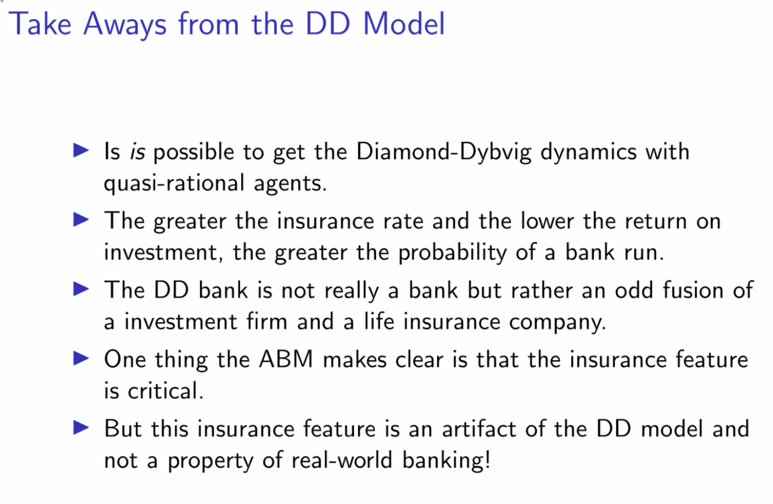

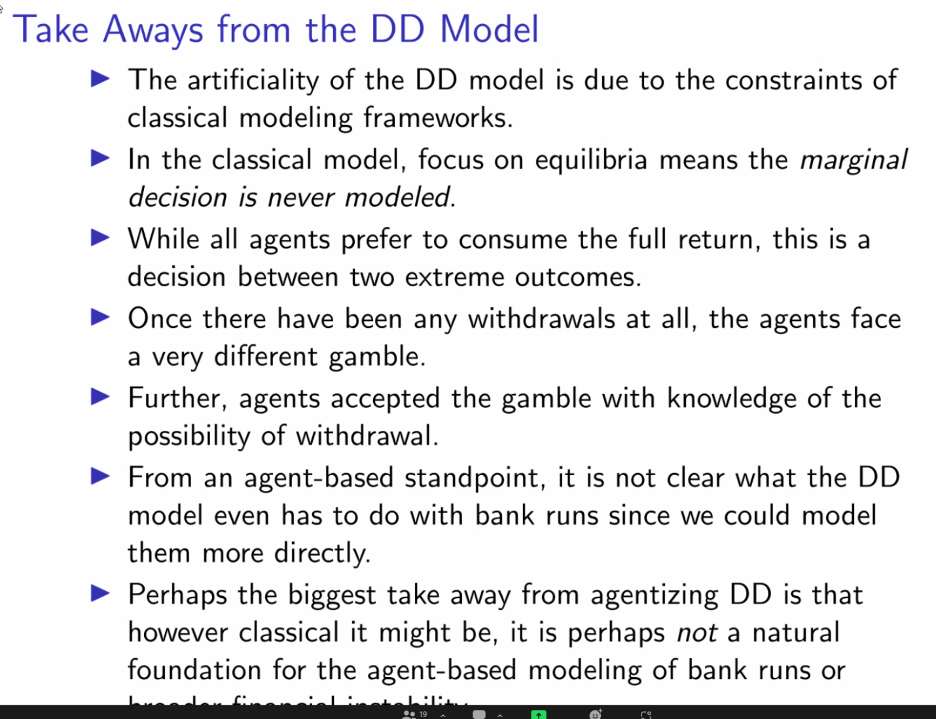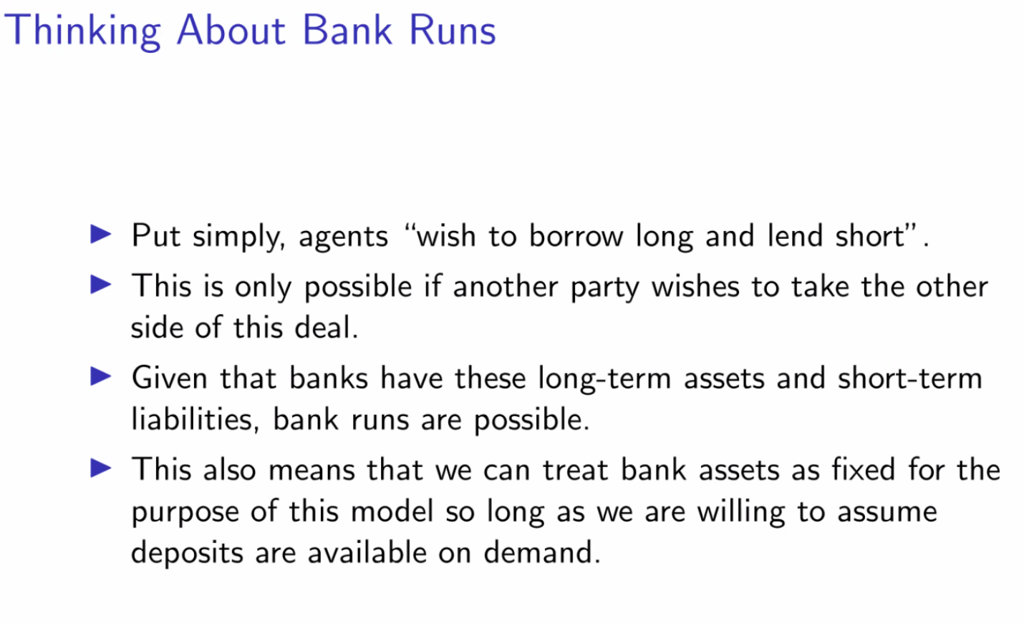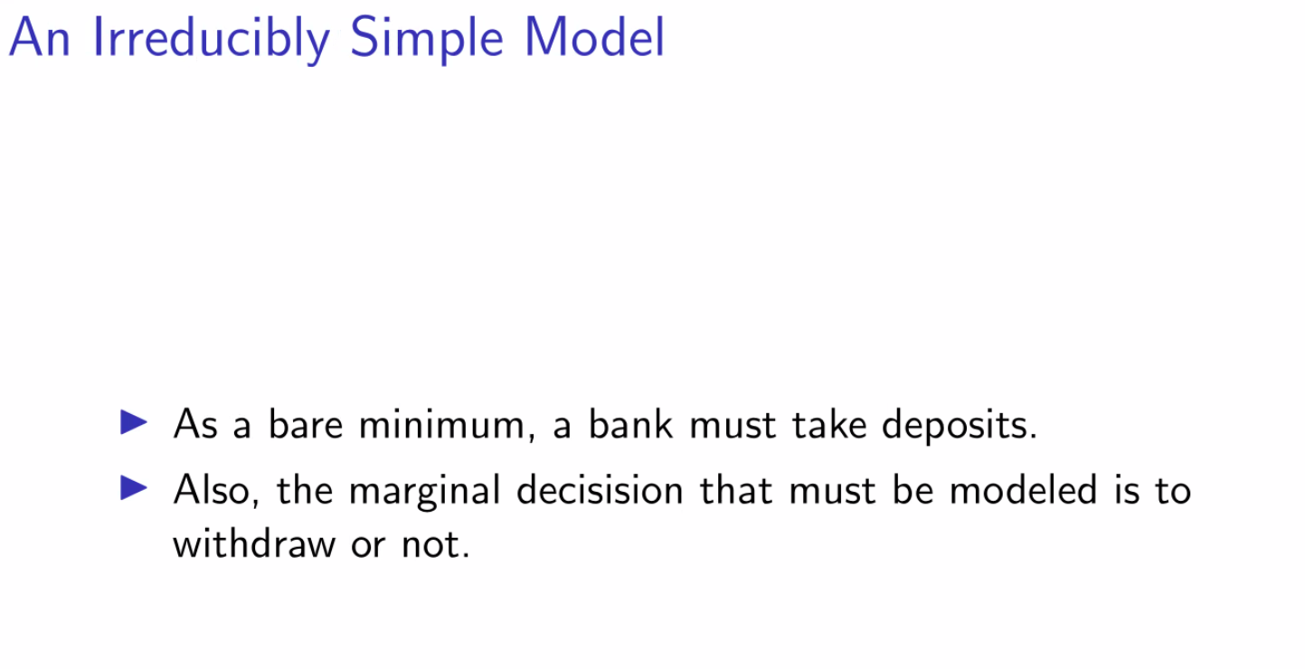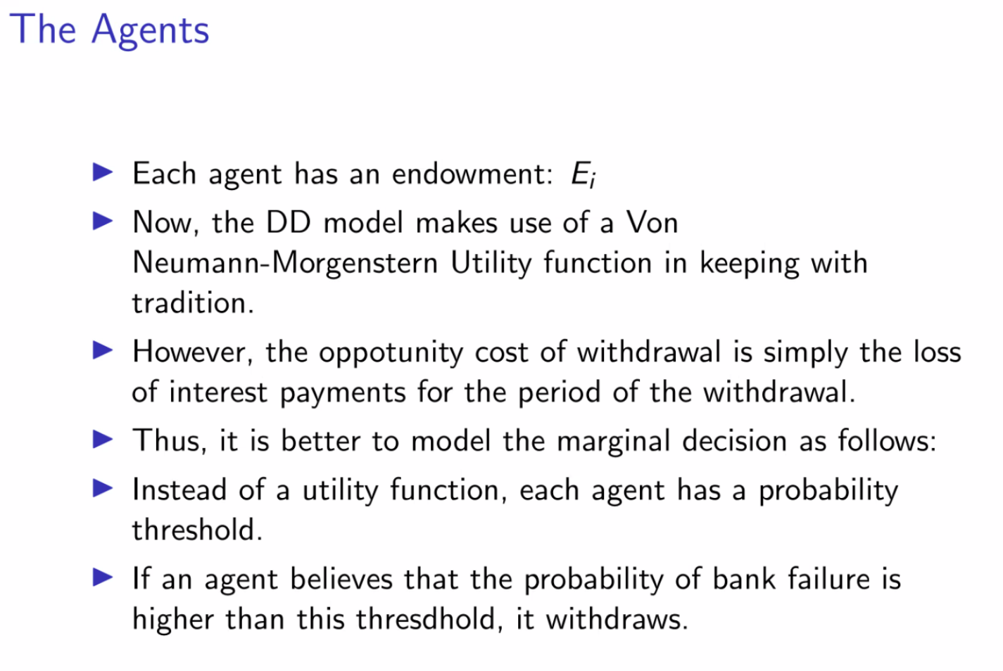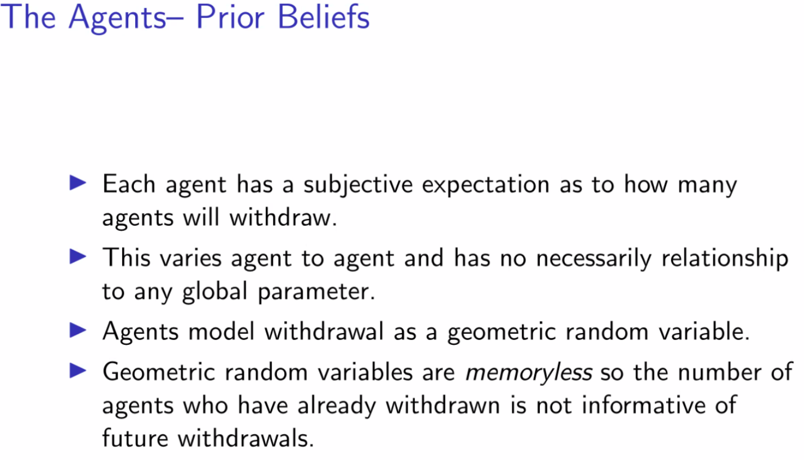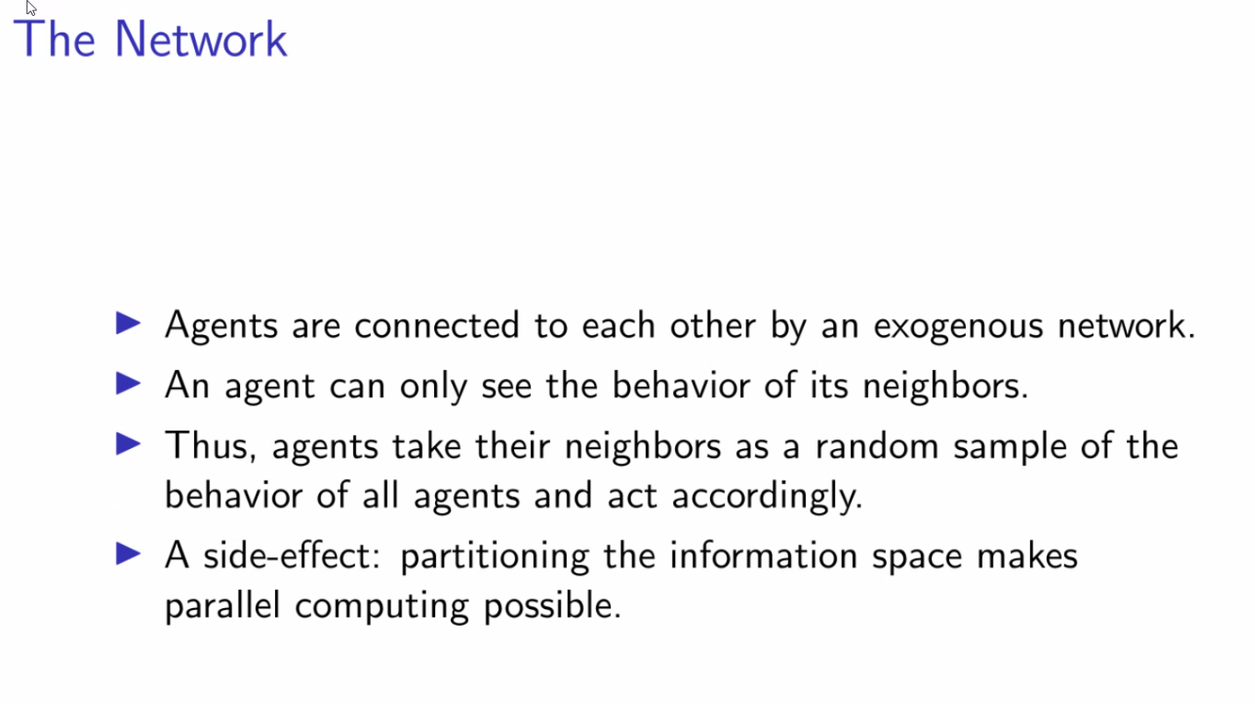

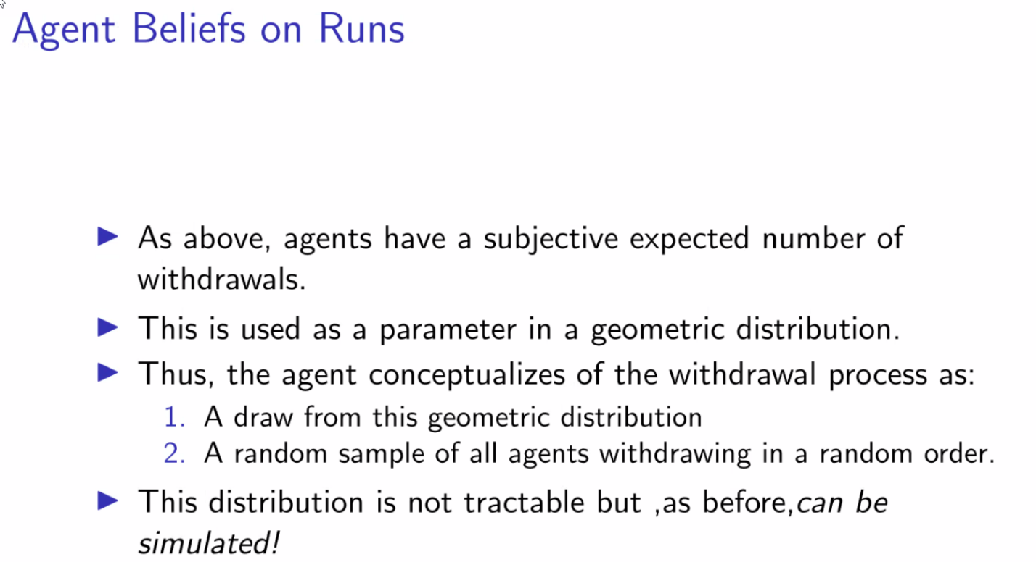

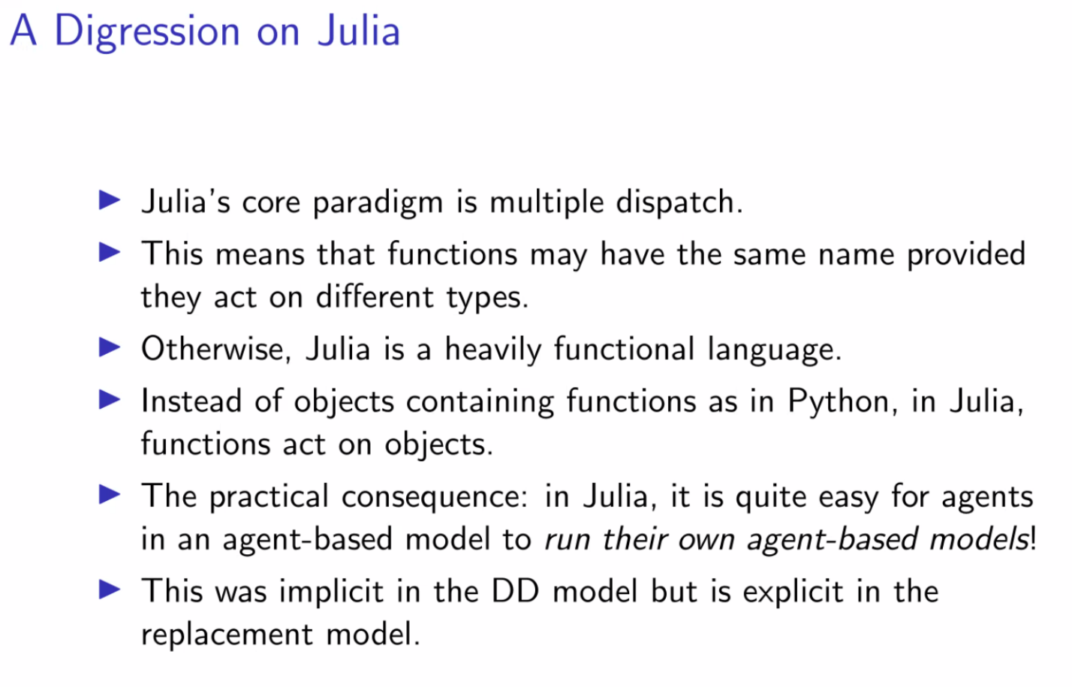

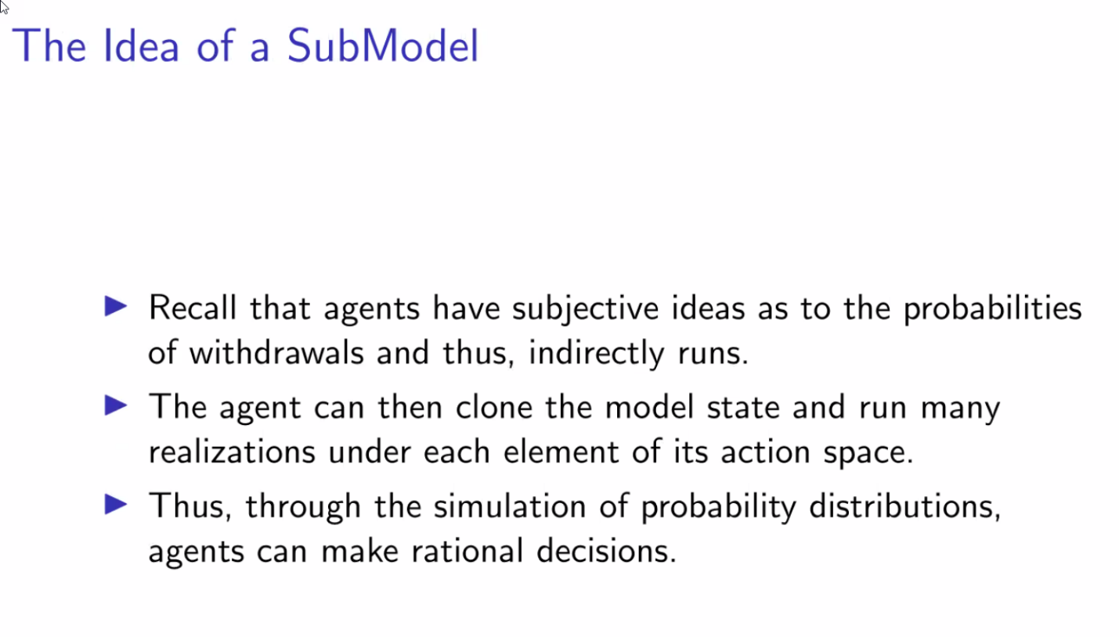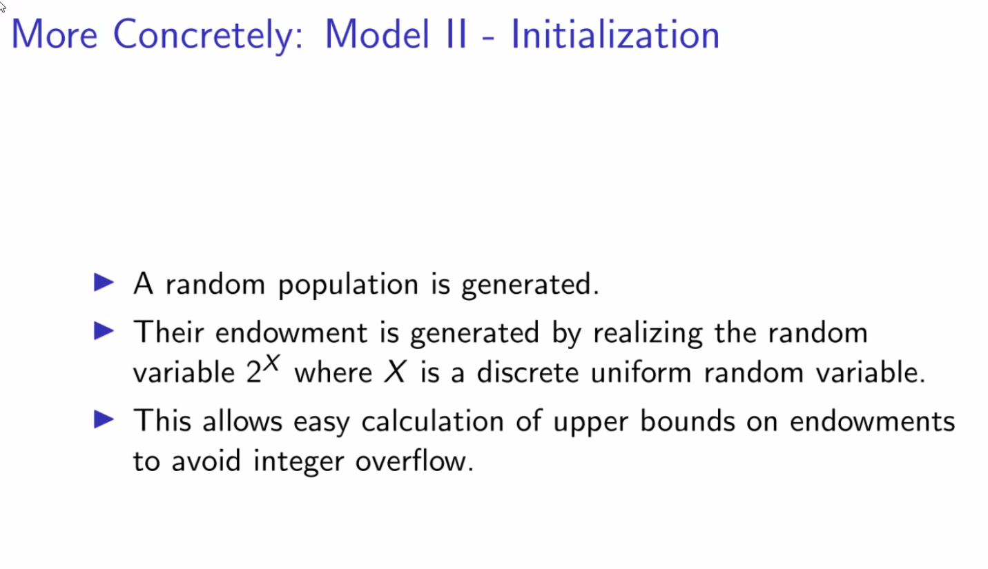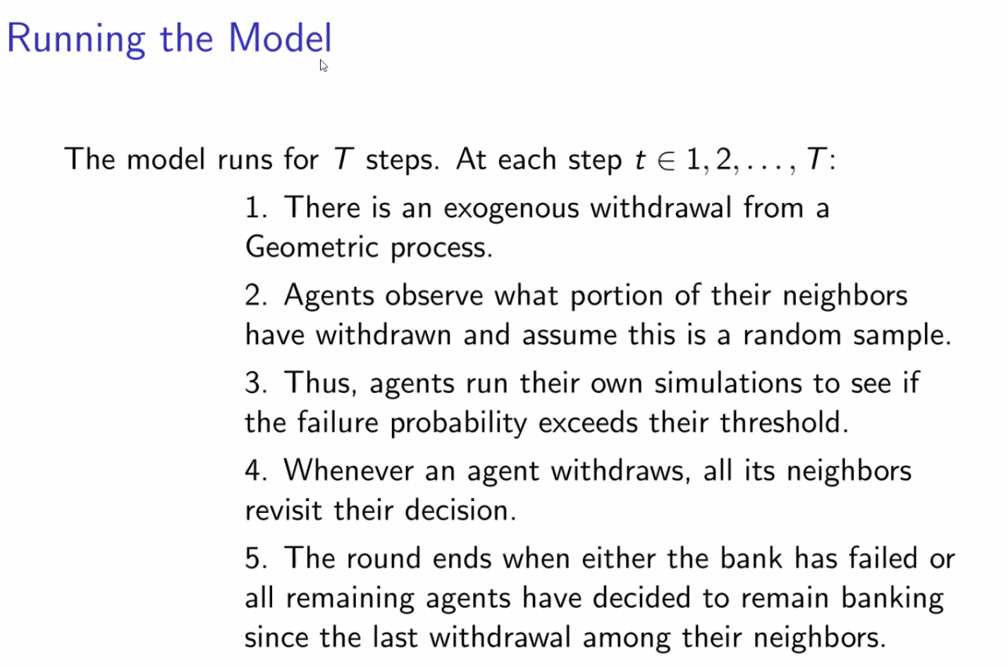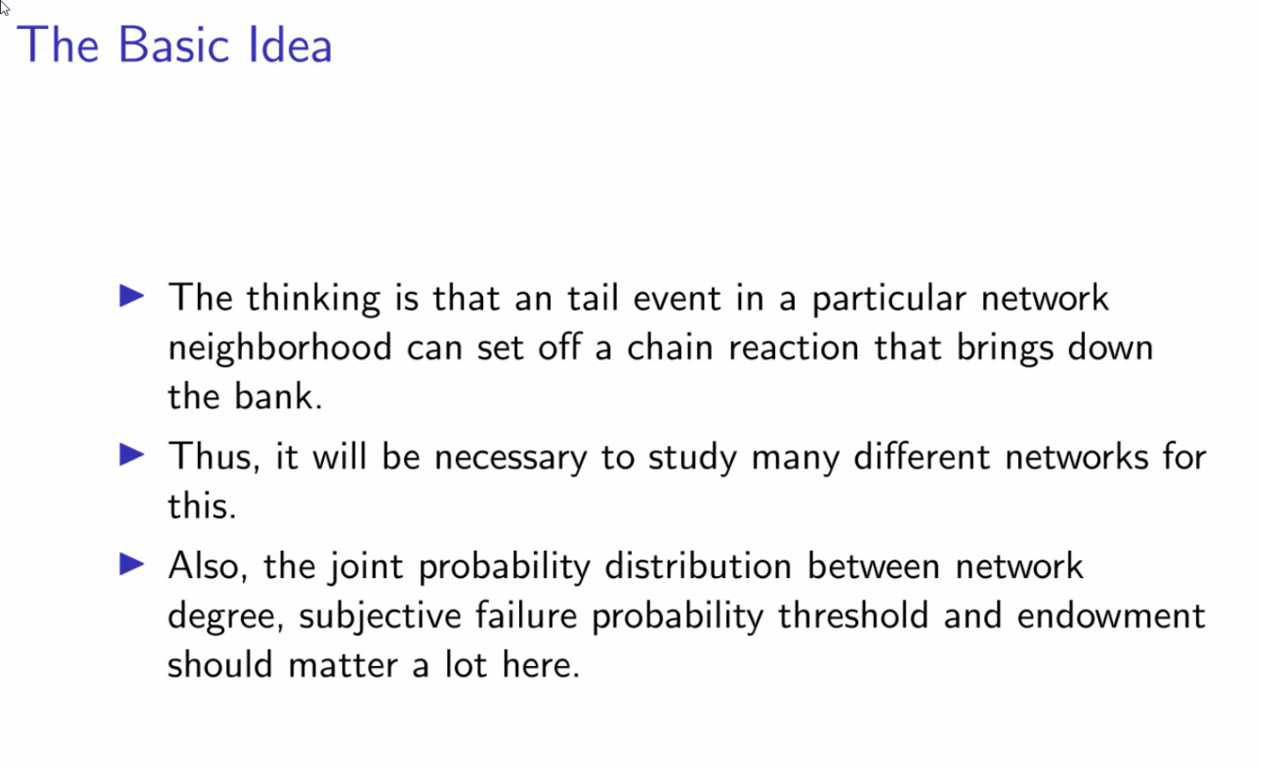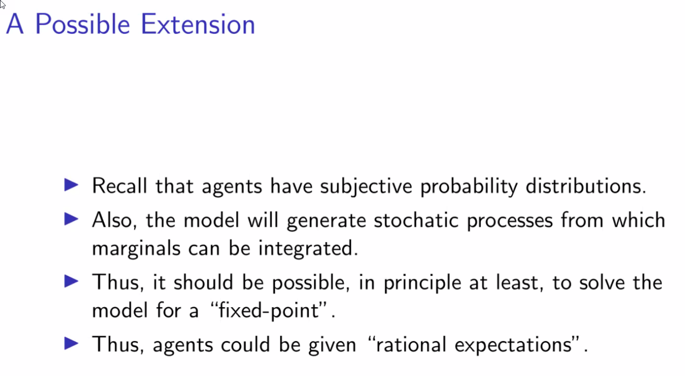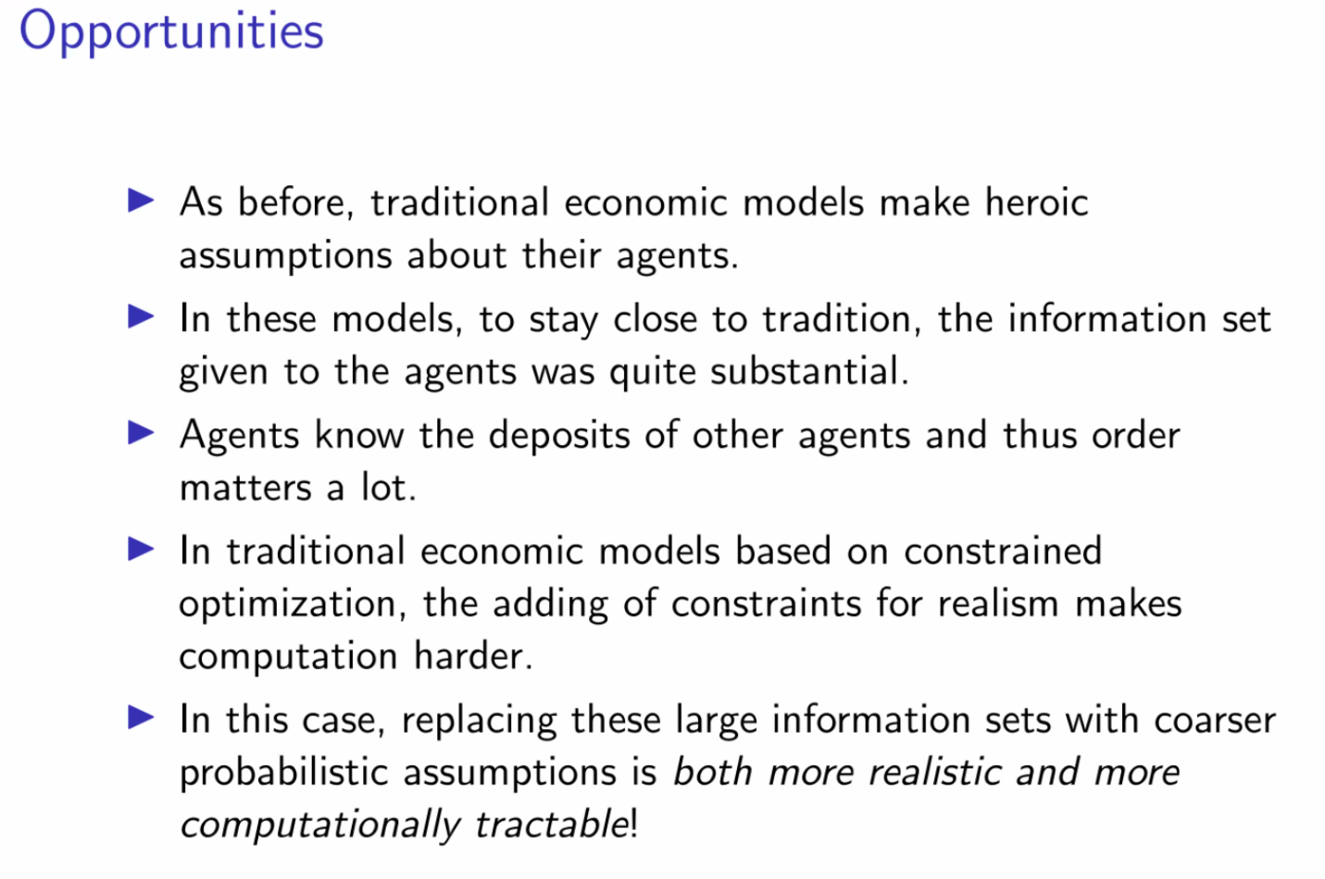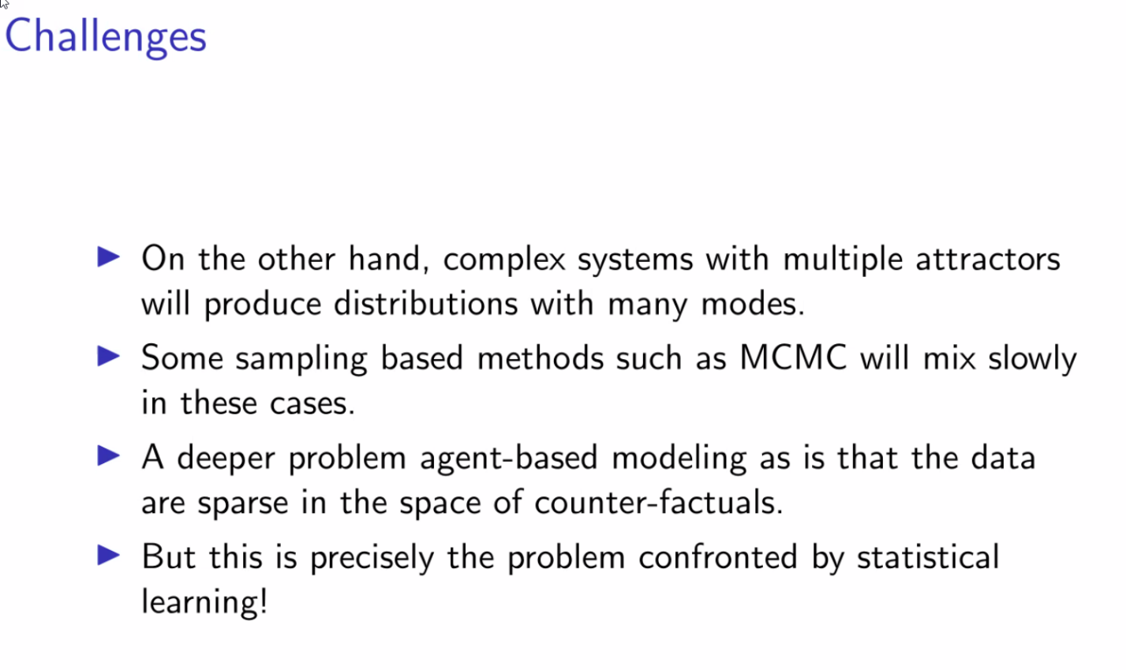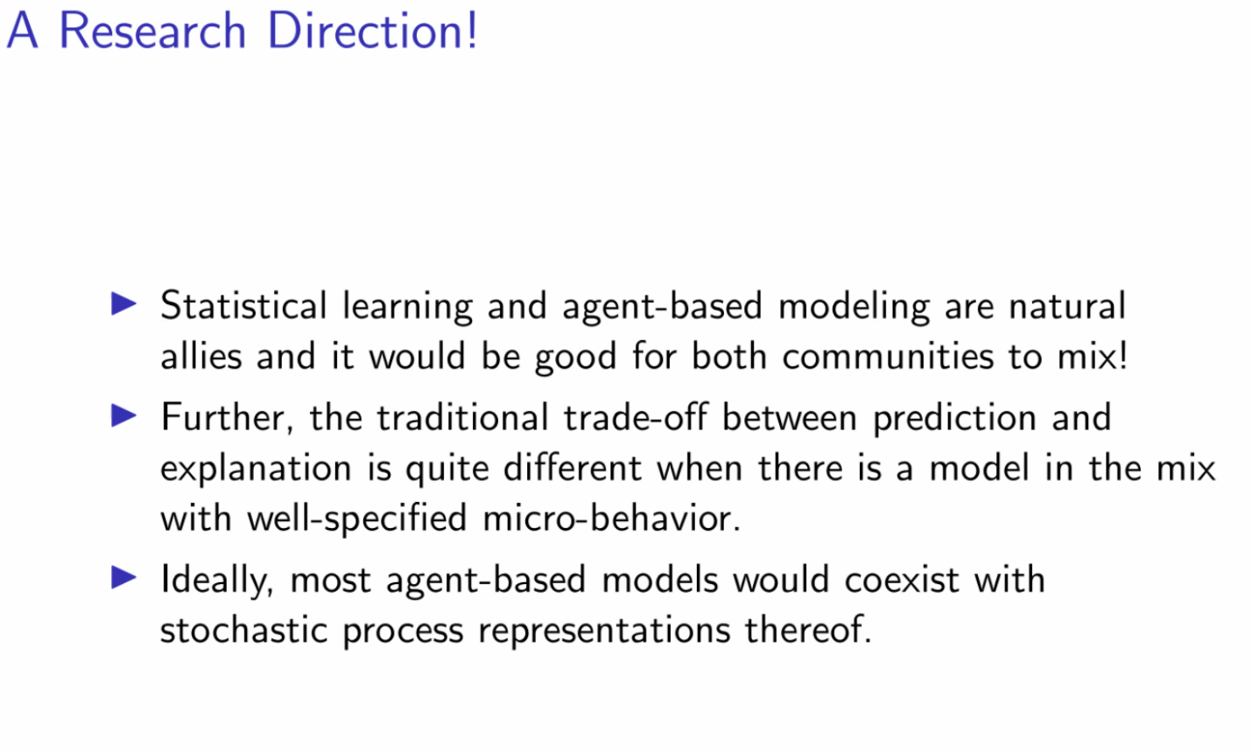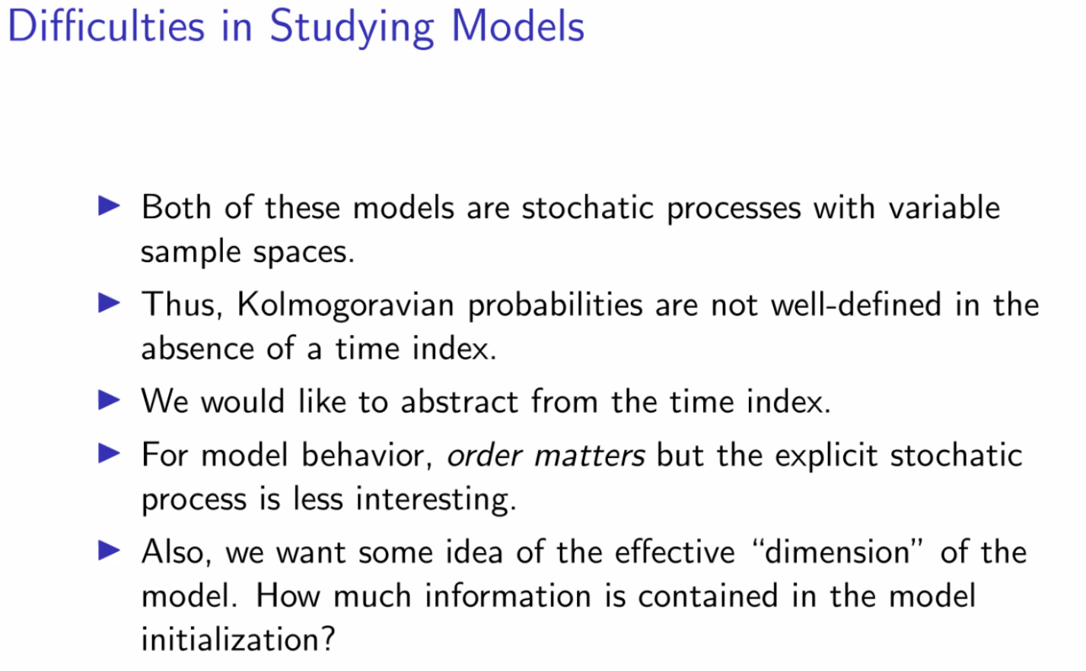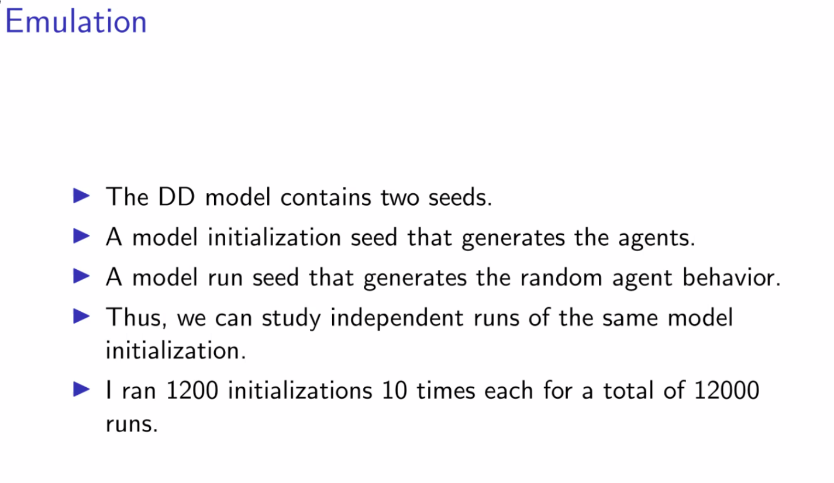

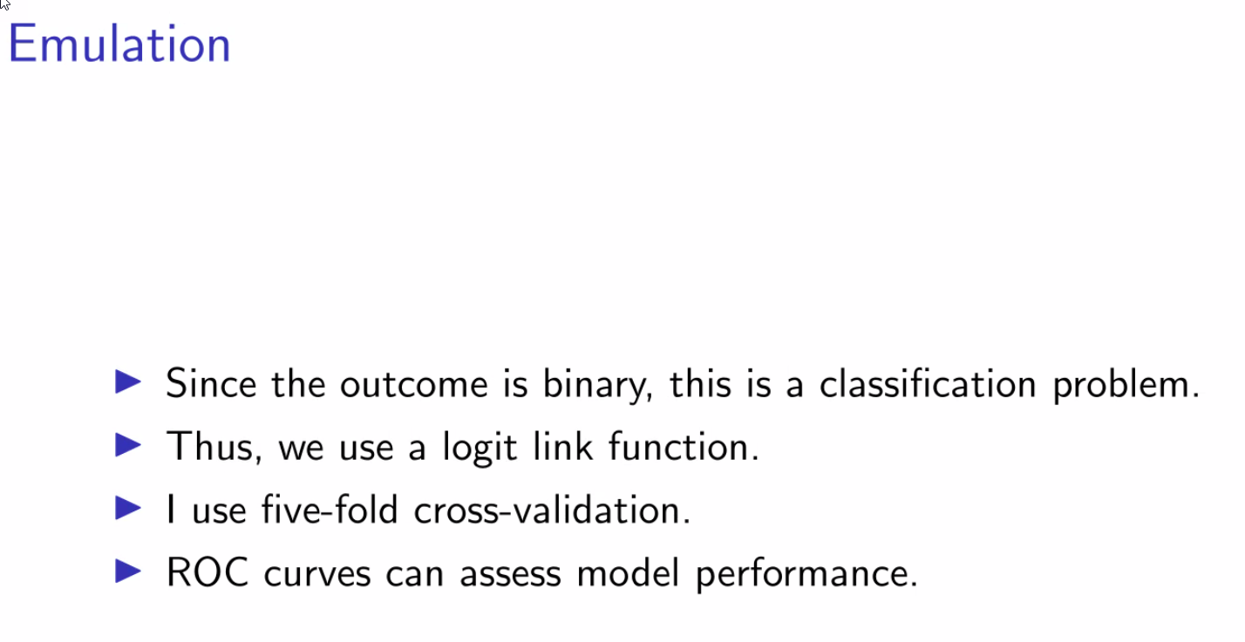

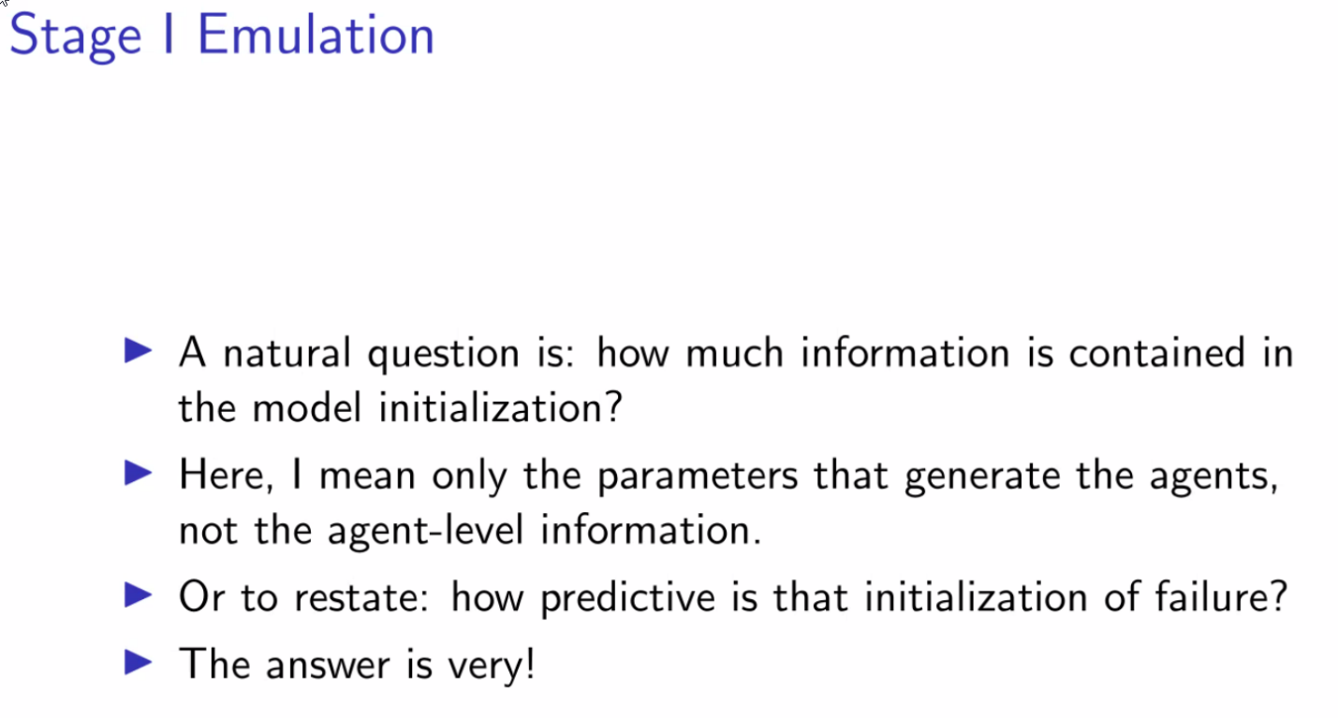

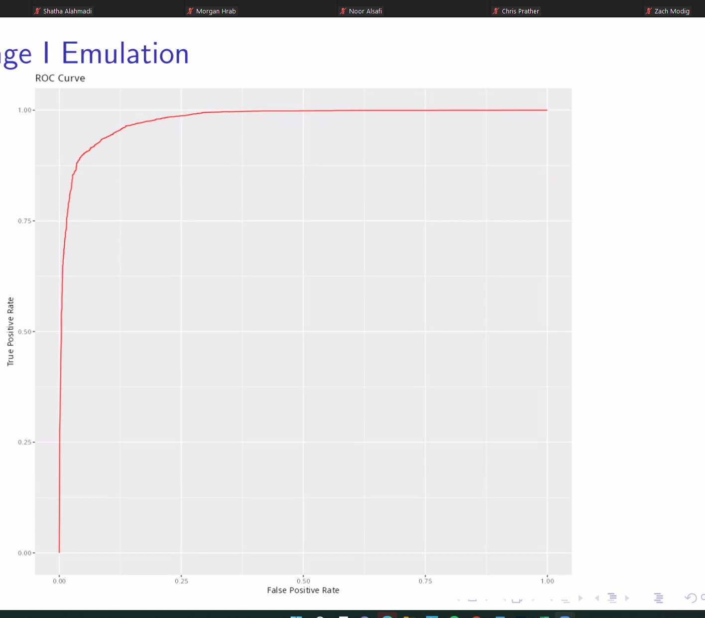

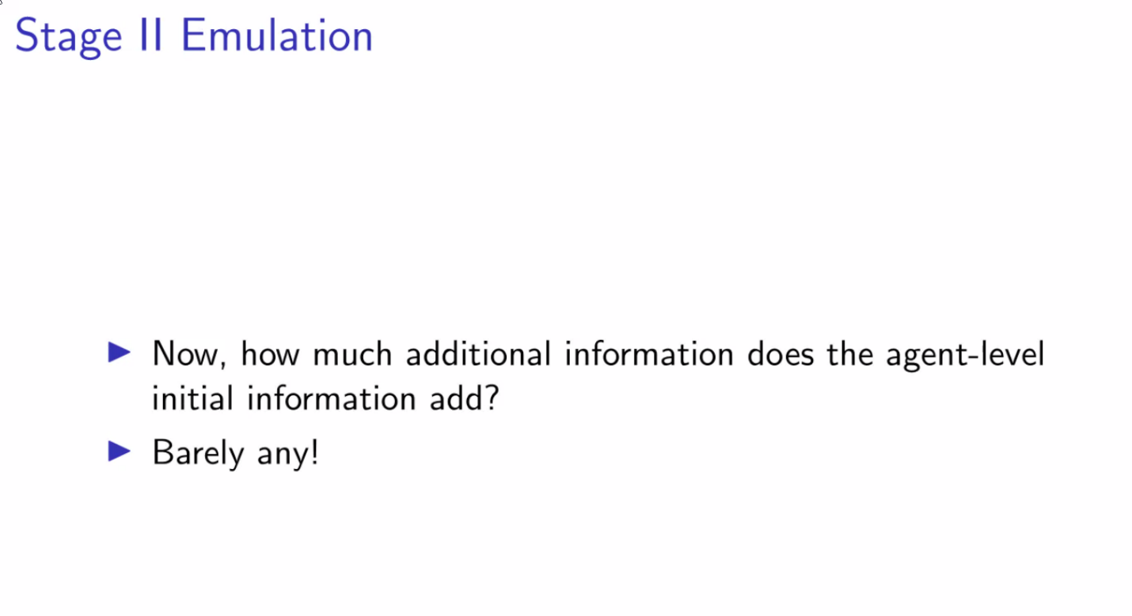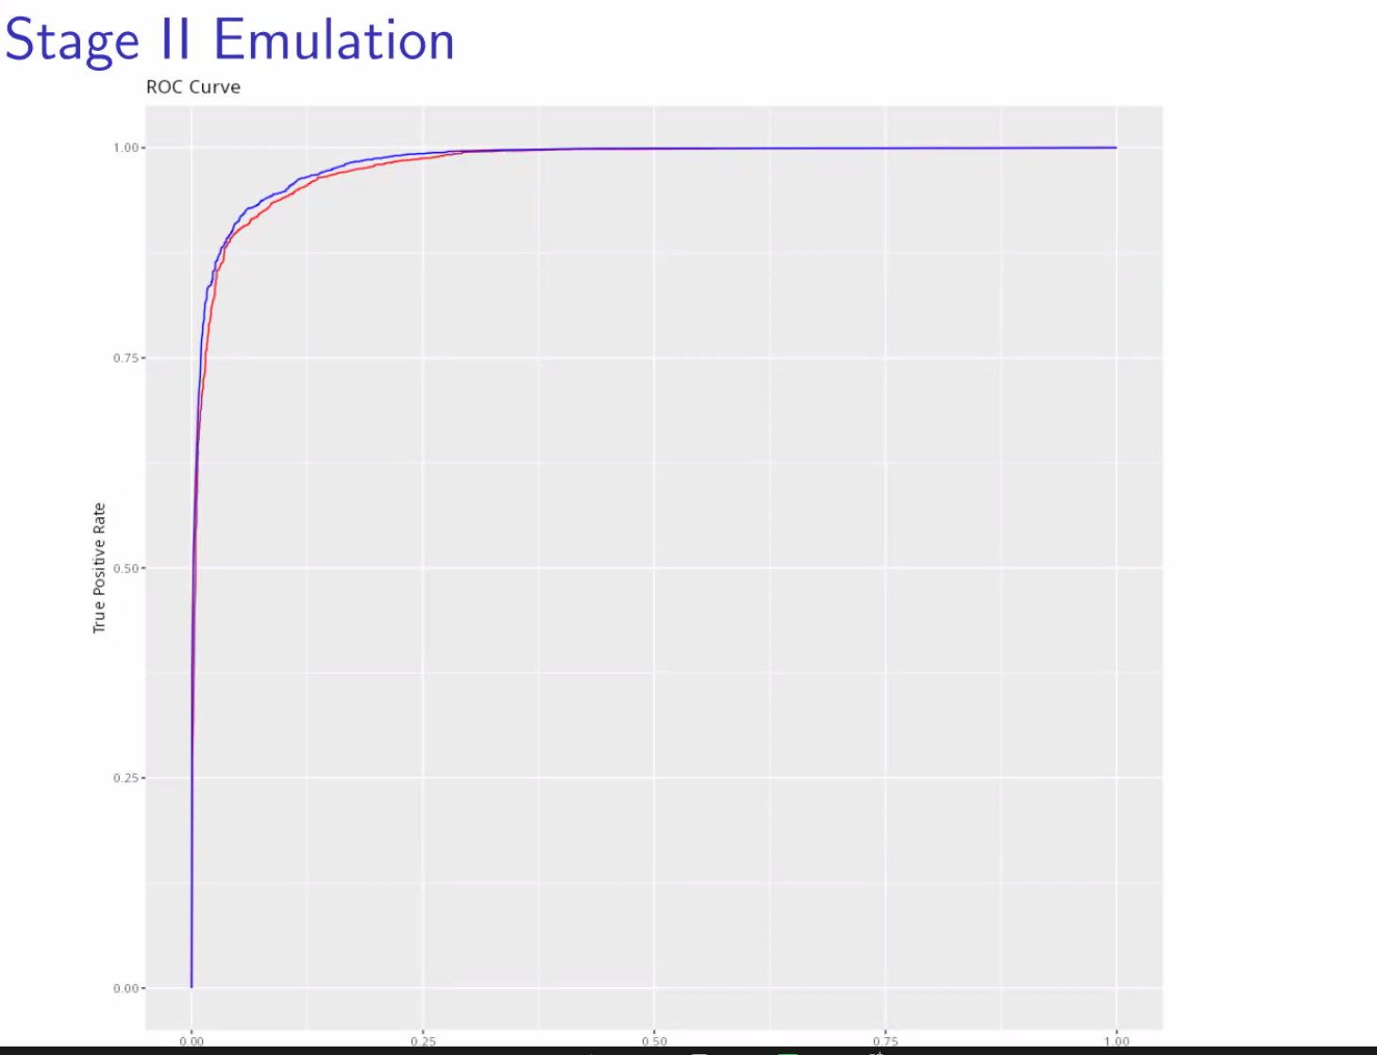

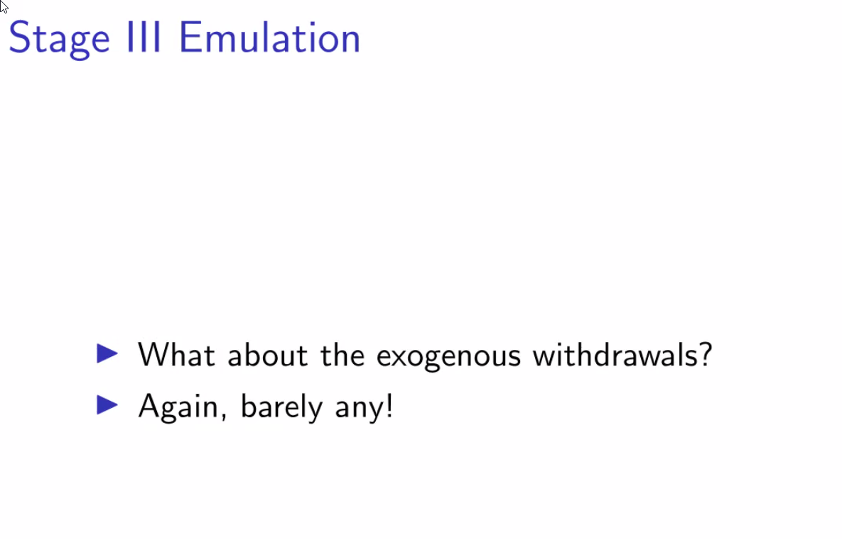

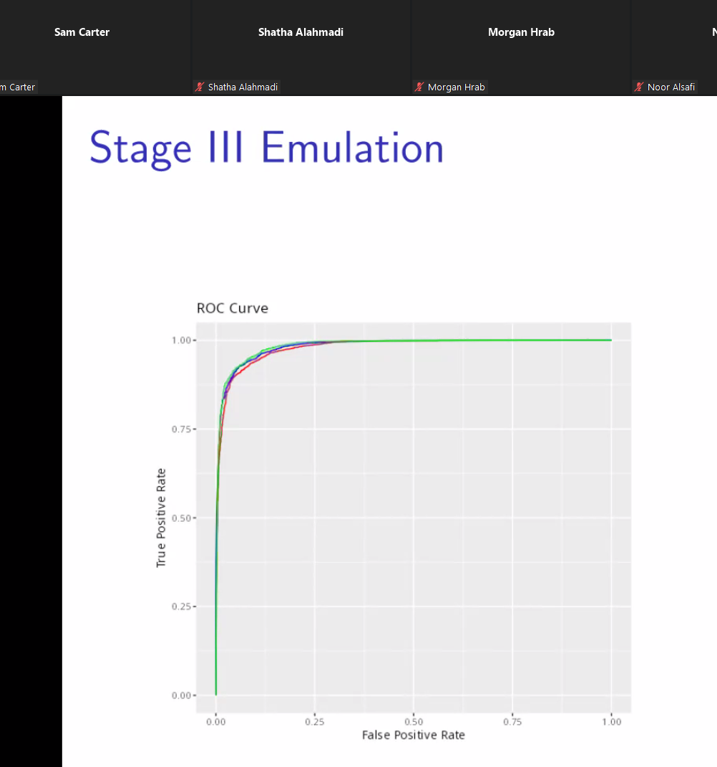

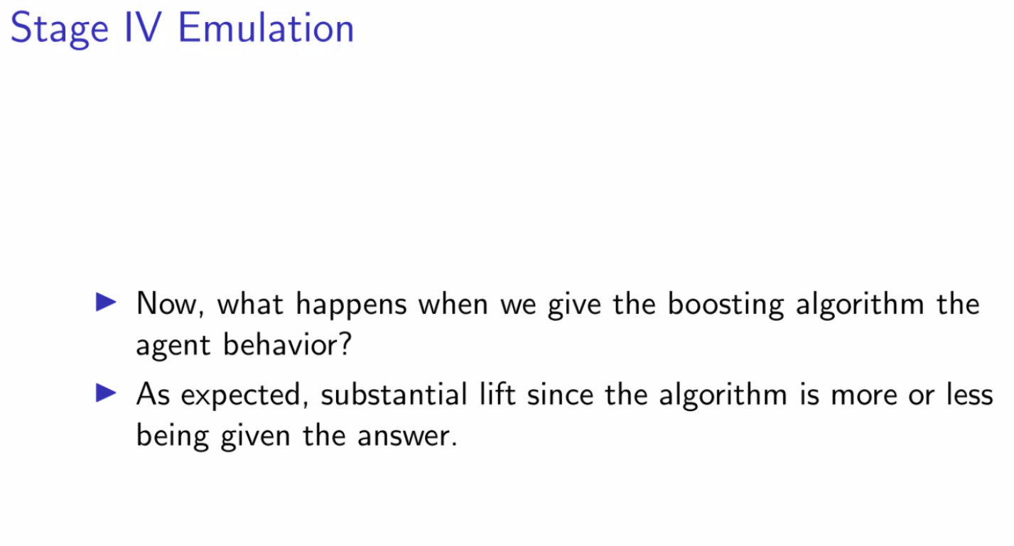

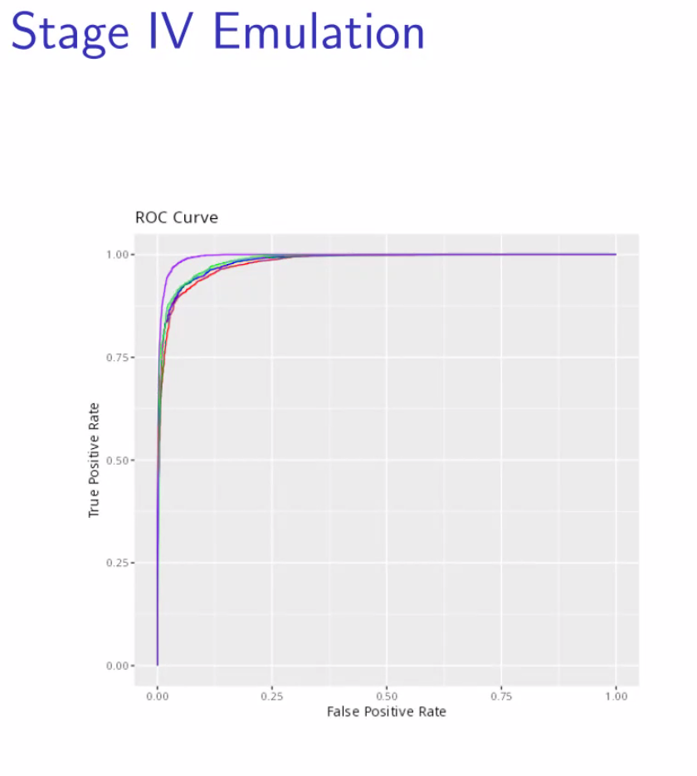

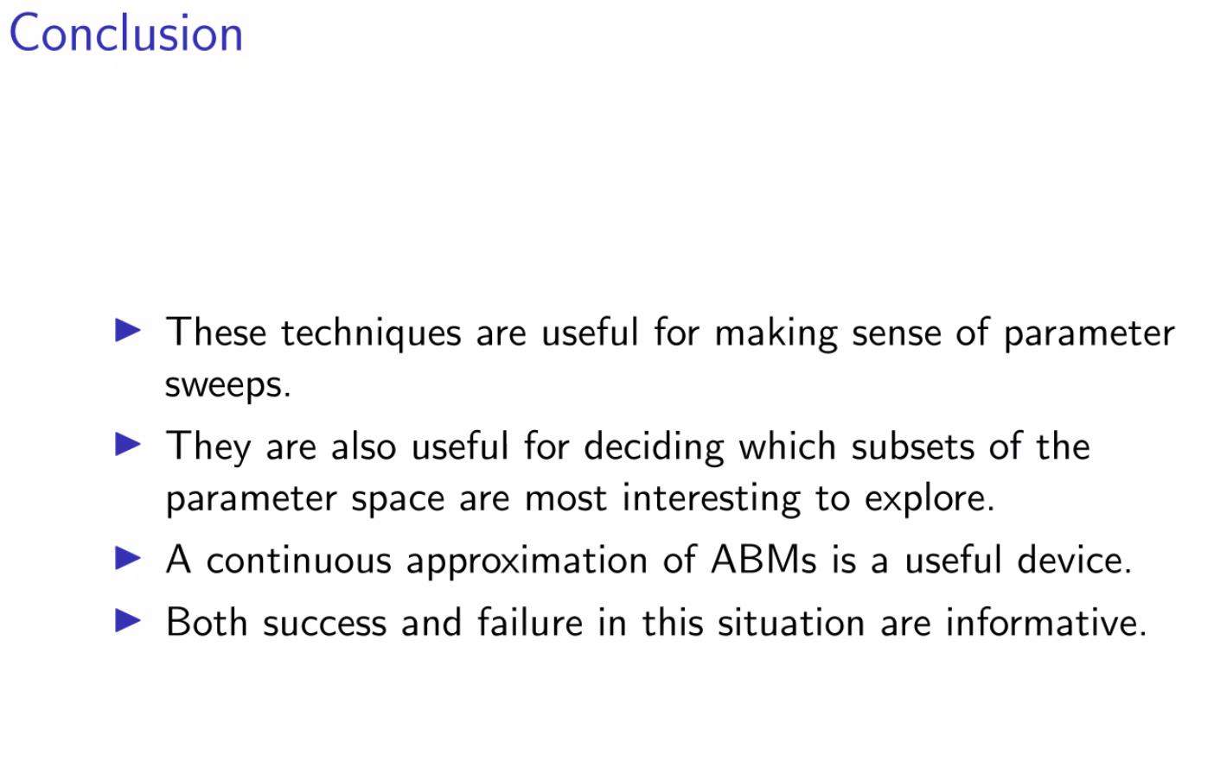

## Week 4 – September 23rd, 2022

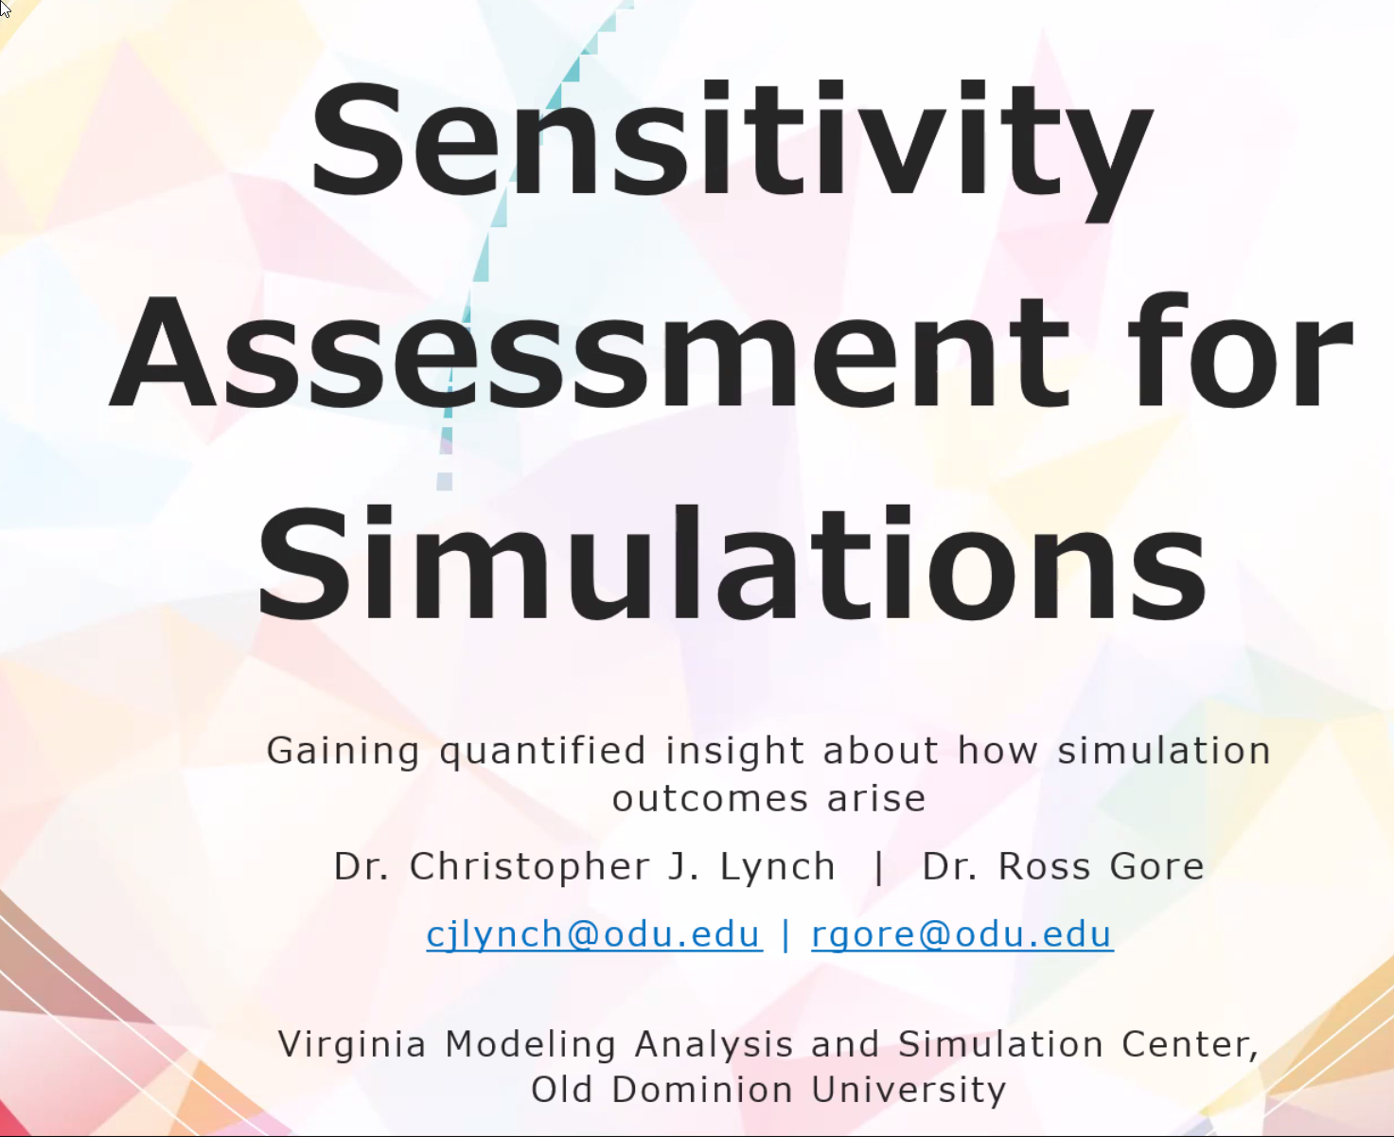

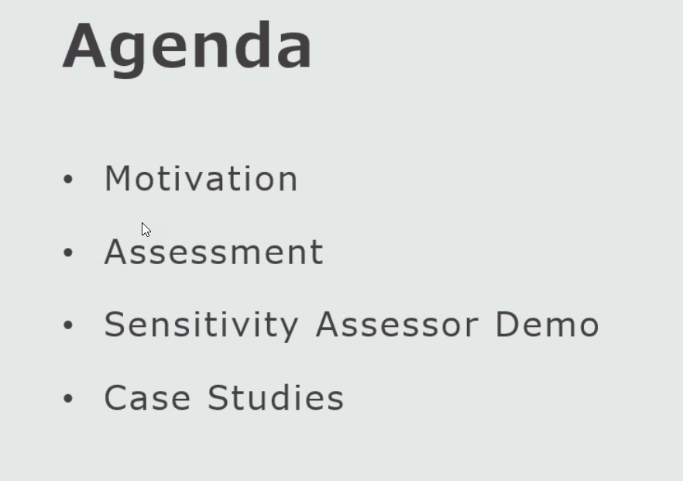

Notes –

Precision and Recall

Geometic, Harmonic Mean

See the Shiny App for example

Hash for ABMs

Uses predicates single, normally distributed

Use basic < relationshiops between pairs of variables

Abstract:

Researchers working with models and simulations, particularly agent-based simulations, can spend hours conducting data analysis of outcomes. For some scenarios, a researcher’s simulation may produce outcomes that match with expectations while for other scenarios it fails to do so. This frustration is not unique. Under circumstances where it is infeasible or impractical to study a system directly, researchers develop simulations to emulate a system's inner workings. When some simulation outputs do not match experimental data, or the prevailing expert opinion, researchers are faced with a challenging problem: does the unexpected output reflect new knowledge about the system or is it due to a bug? Researchers can spend years studying their simulation source code to make this determination.

Motivated by the high cost and labor-intensive nature of identifying conditions and source code statements that drive a simulation towards an unexpected output we developed the Sensitivity Assessor. The Sensitivity Assessor is an online tool ([https://vmasc.shinyapps.io/SensitivityAssessor/](https://nam11.safelinks.protection.outlook.com/?url=https%3A%2F%2Fvmasc.shinyapps.io%2FSensitivityAssessor%2F&data=05%7C01%7Cjboone%40gmu.edu%7Cb307e0bdd41c422048c908da9bfc8243%7C9e857255df574c47a0c00546460380cb%7C0%7C0%7C637993806075917893%7CUnknown%7CTWFpbGZsb3d8eyJWIjoiMC4wLjAwMDAiLCJQIjoiV2luMzIiLCJBTiI6Ik1haWwiLCJXVCI6Mn0%3D%7C3000%7C%7C%7C&sdata=hyTZbA4WV3xB1%2BqU2pYRREMgoiSOLJwvN%2B%2Fcqe%2FMsSw%3D&reserved=0)) built to identify conditions and variables within a simulation that are consistently driving the simulation towards an outcome of interest.

This talk details how to take data generated directly from simulations, (1) convert that data into a form that is ingestible by the Sensitivity Assessor using an automated converter, and (2) analyze the data using the Sensitivity Assessor. This work has been developed at the Virginia Modeling, Analysis, and Simulation Center of Old Dominion University by members of the Data Analytics Working Group. Our tools are public facing and free to use.

Speaker bios:

**Christopher J Lynch** is a Lead Project Scientist at the Virginia Modeling, Analysis, and Simulation Center of Old Dominion University. His research focuses on data science, data analytics, and health informatics for building properly constructed and defensible narratives about analytic outcomes. He serves as a data curator; leveraging a combination of data ethics and statistical reporting standards to convey credible, transparent, and reproducible analyses. Through this theme, he contributes to the development of publicly accessible analytic tools and services as well as verification, validation, and data exploration methods for simulation environments.

**Ross Gore** is a Research Associate Professor in the Virginia Modeling, Analysis & Simulation Center at Old Dominion University. His research focuses on extracting, combining, and analyzing data from new and diverse sources to provide quantitative and interpretable answers to questions. This analysis can take the form of analysis, statistical models or simulations. The domains of the questions have varied from public health, refugee migration, city planning, terrorist attack risk assessments, cyber security, software engineering and social science. The unifying theme across my work is the use of novel data sources to improve understanding of the problem at hand.